After login Cpanel. Do three task

1. We need to set php current version
2. Database Create
3. Project File Upload

How to set php current version:

Write “php” at top bar 🡪 select PHP Version

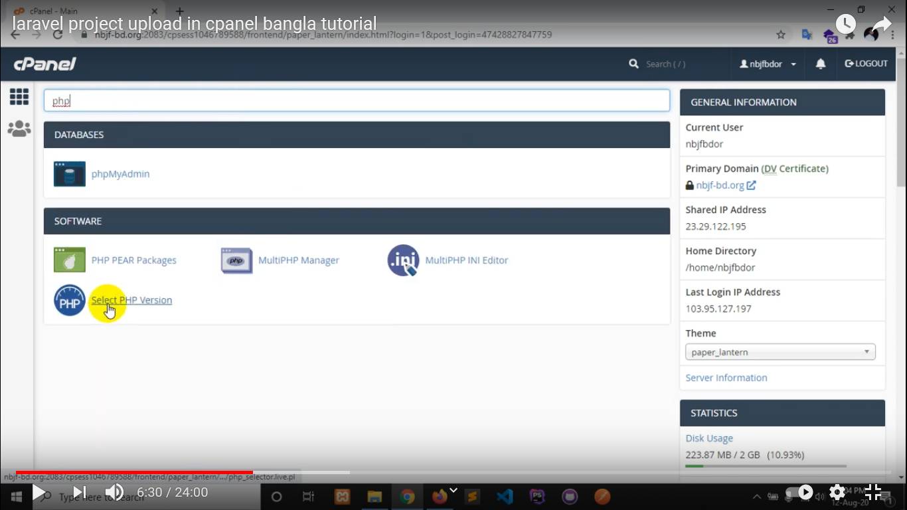

Select last version like below

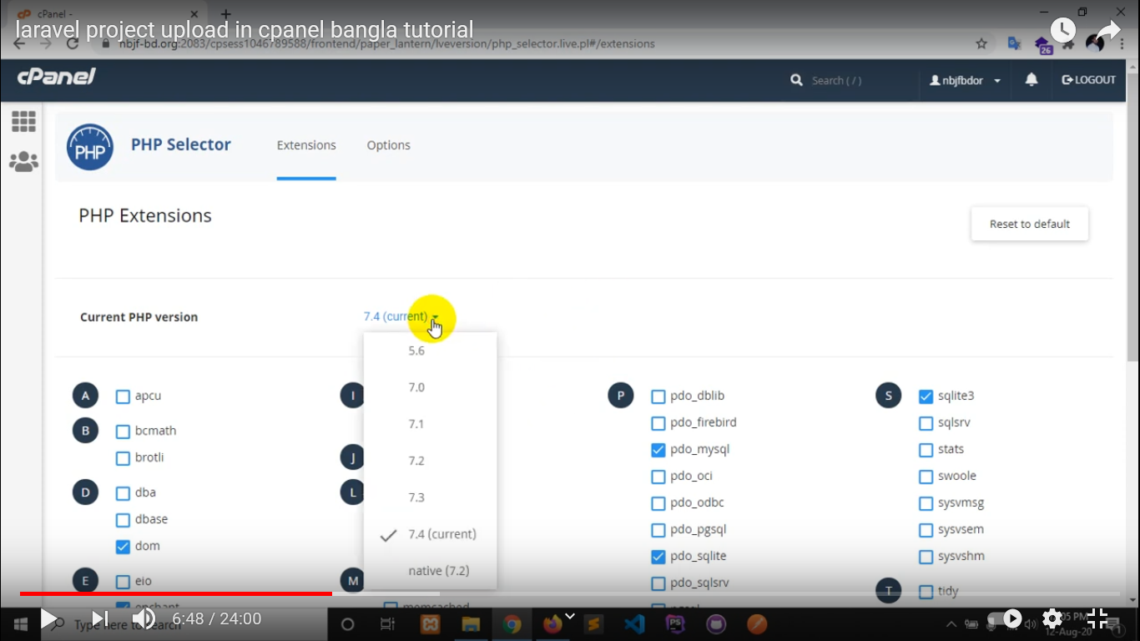

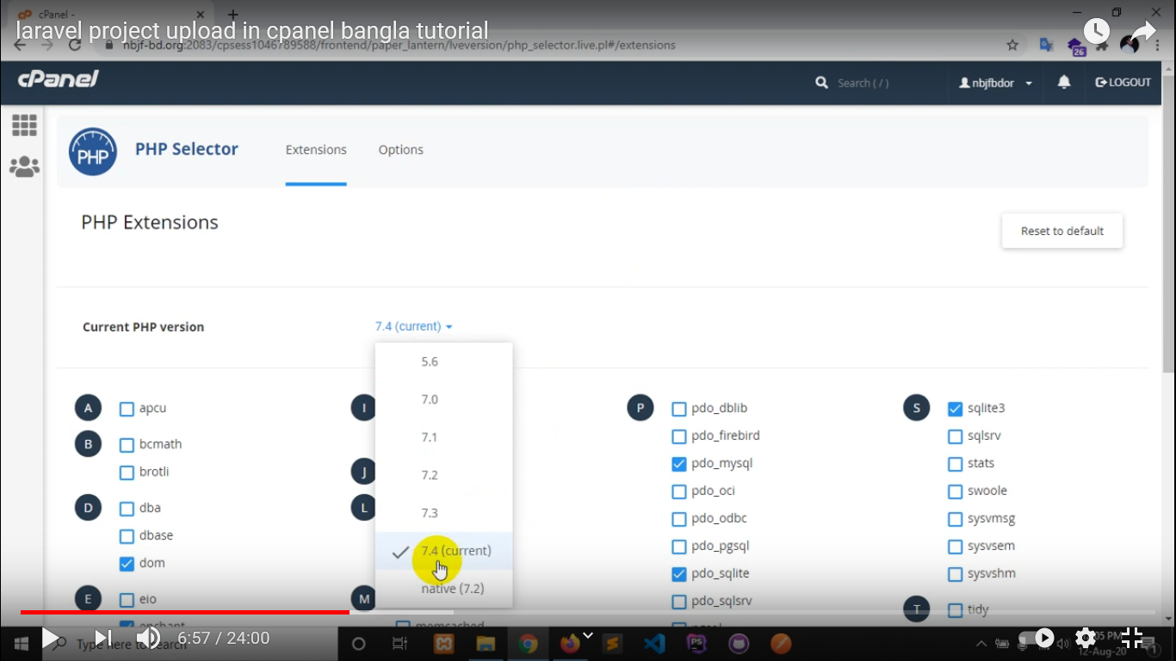

For save click on “set as current”

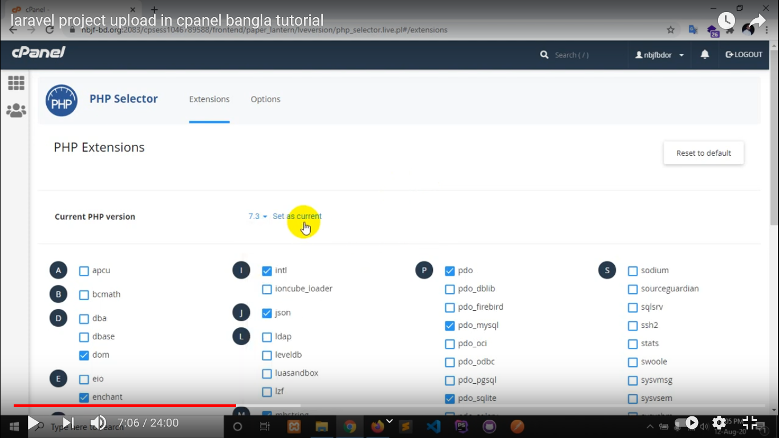

**How to create Database in Cpanel:**

Click on “My Sql &Databases”

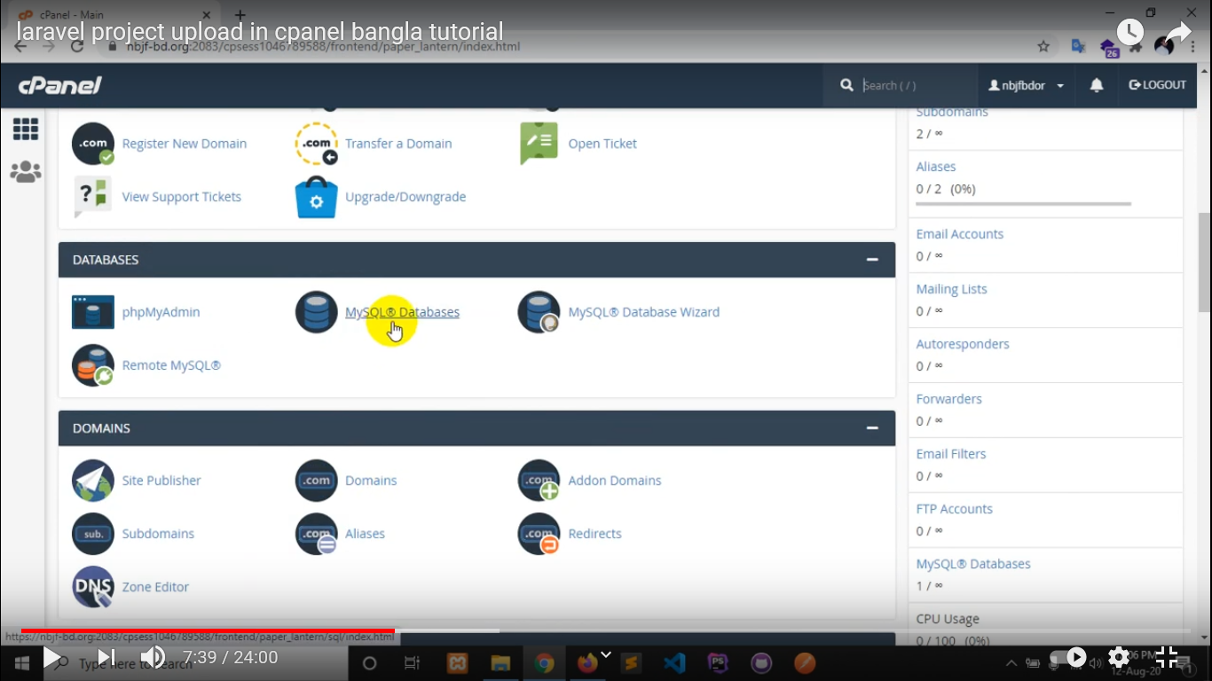

Give a name of your database 🡪 “Create Database” click here [open a note pad and write db name]

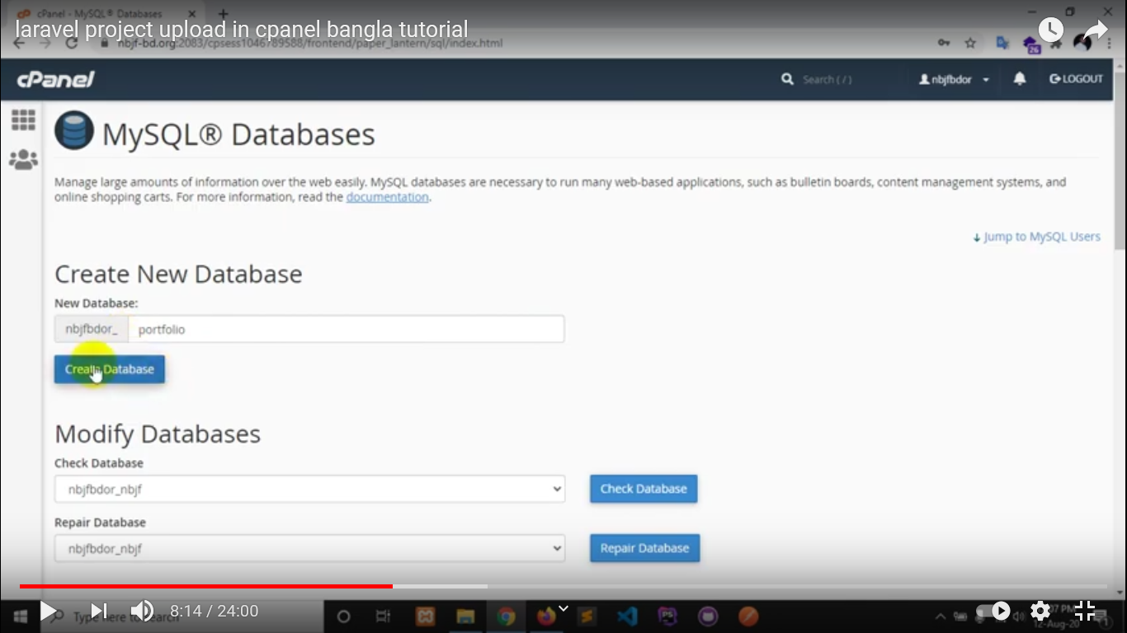

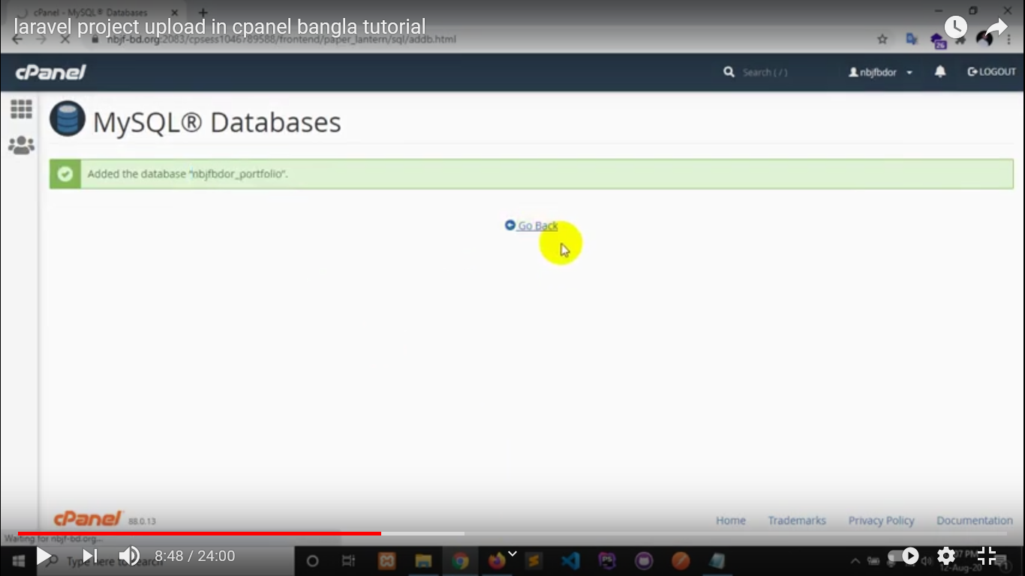

Now, Create a username and password of your database [save username and password in Note pad]

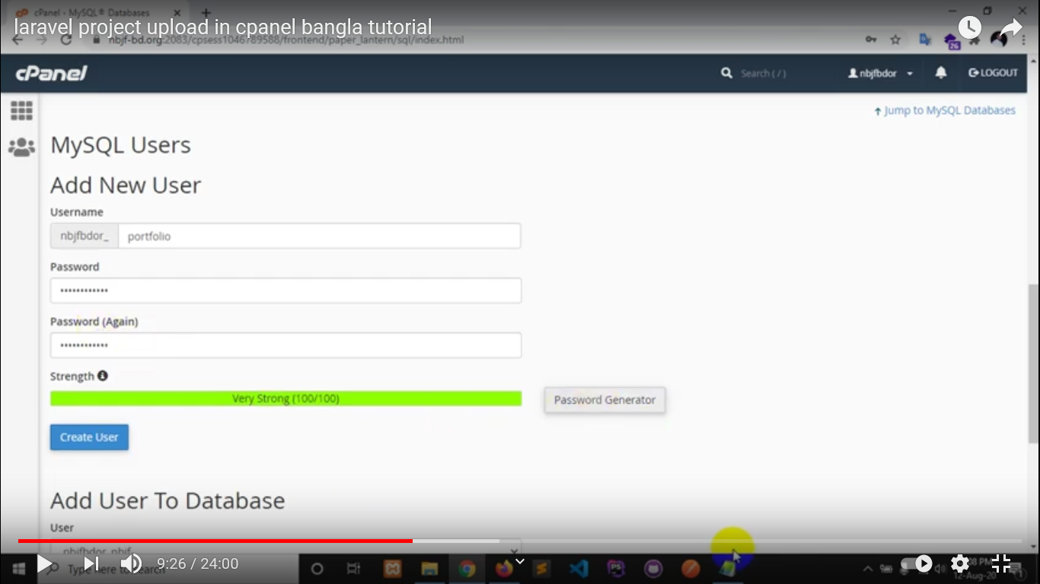

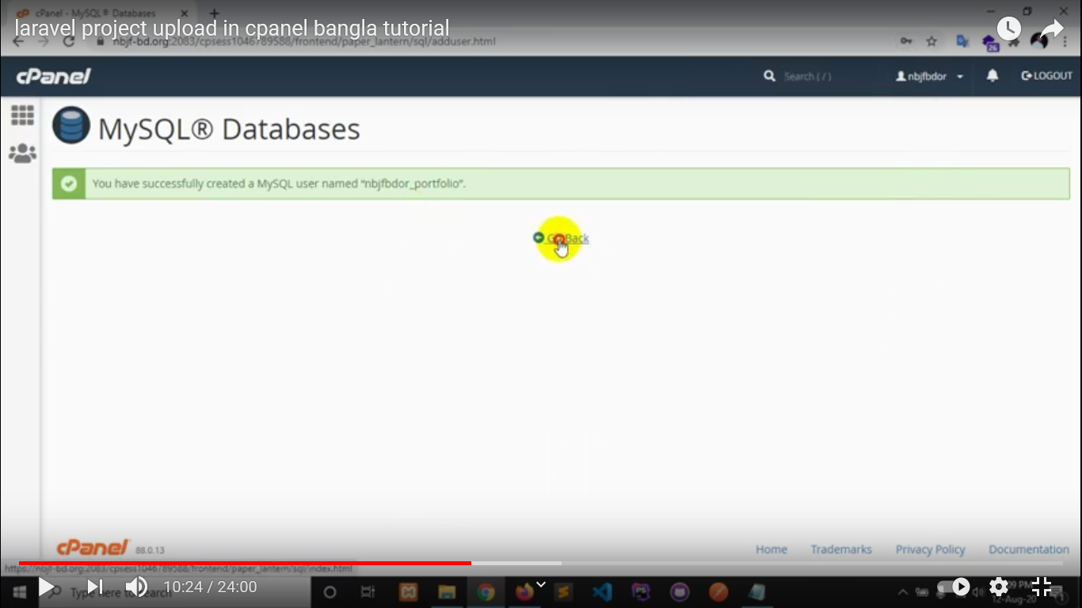

Now, connect database usename with database. 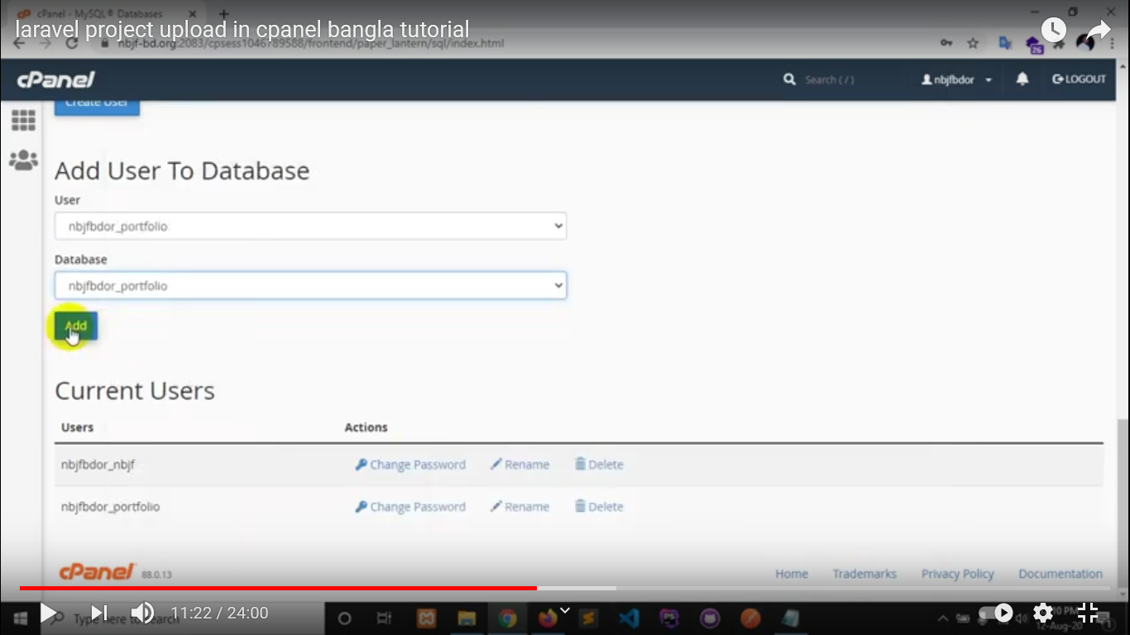

After connect click on “Add” button

Now set database privileges

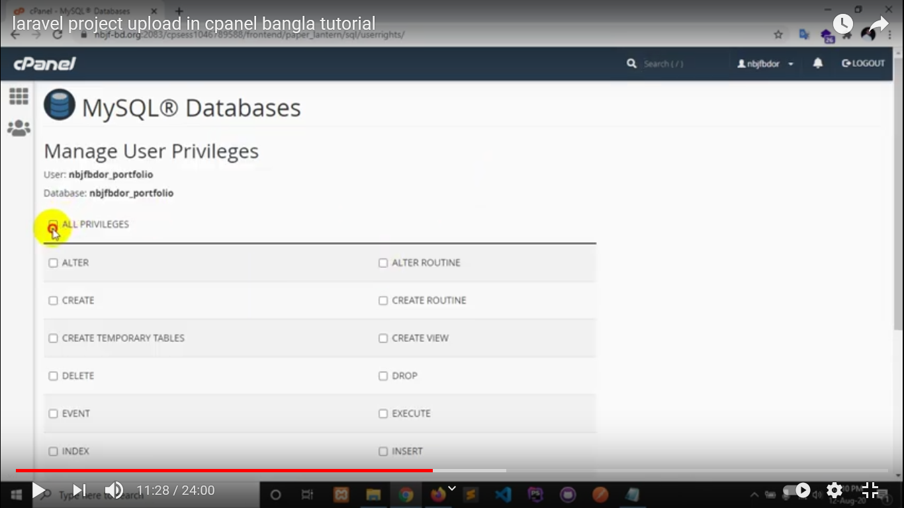

Click on “ALL PREVILEGES” 🡪 Make Changes

**Import Database**

Now we need to import our database in cpanel, to do that click “PHP My Admin”

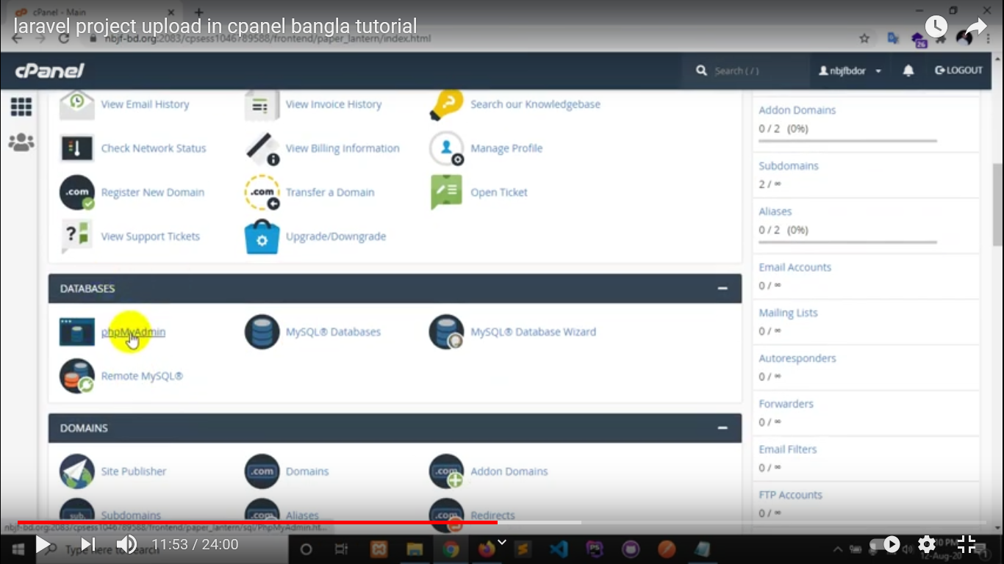

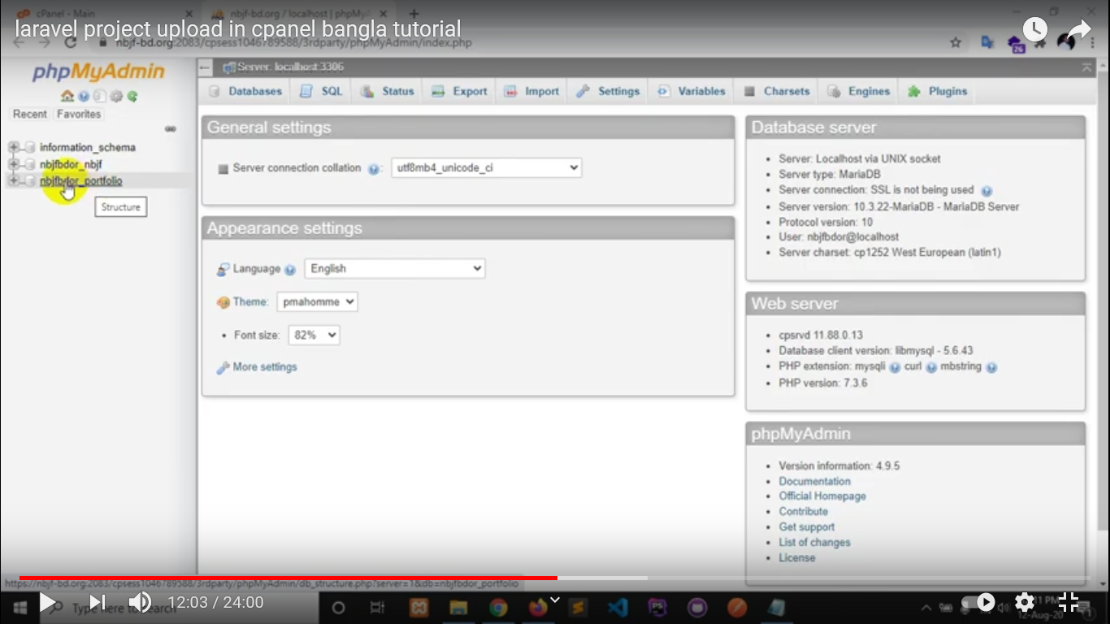

Select database first and then click on “Import”

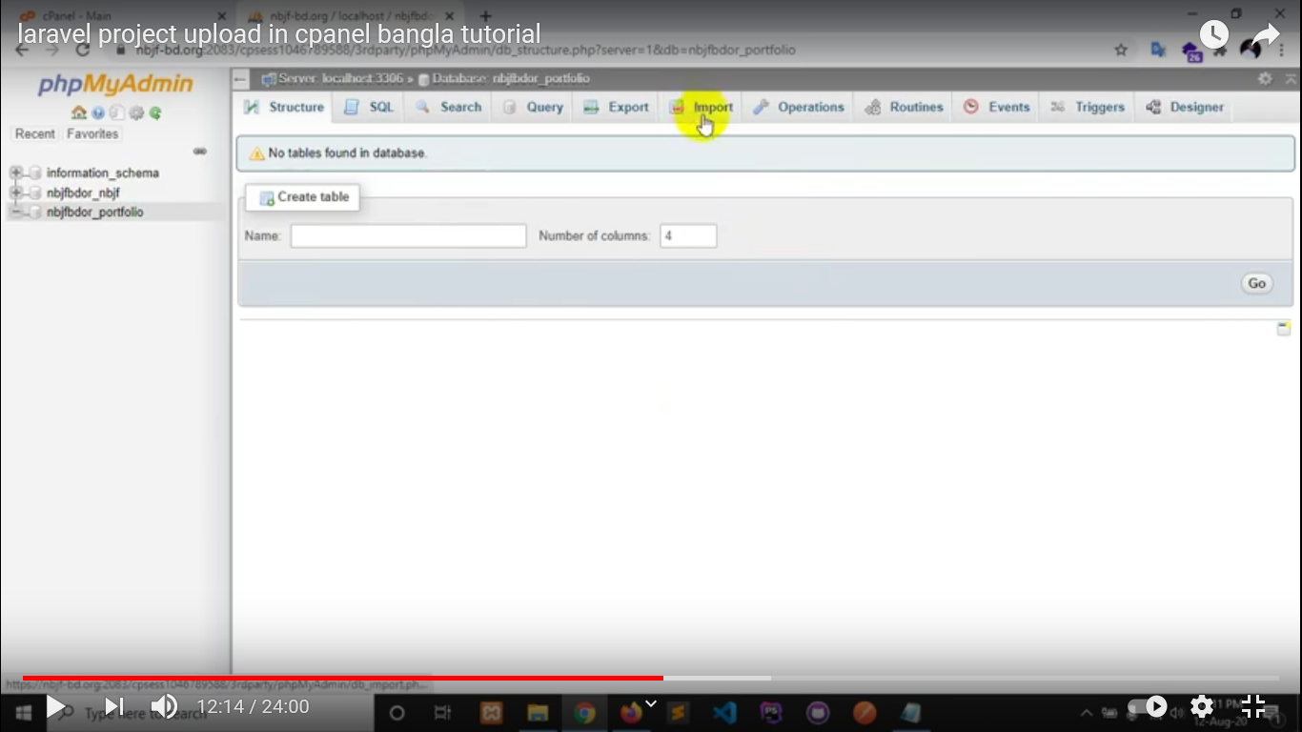

Choose your database file

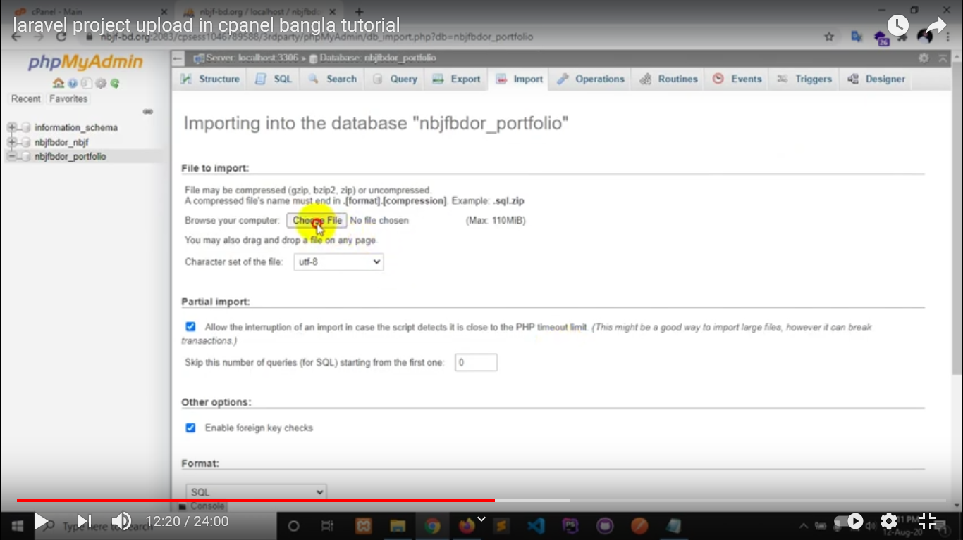

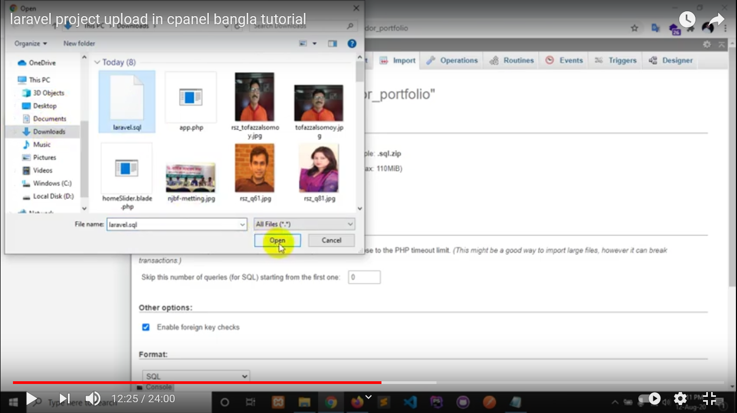

Click on “Go” button to upload database

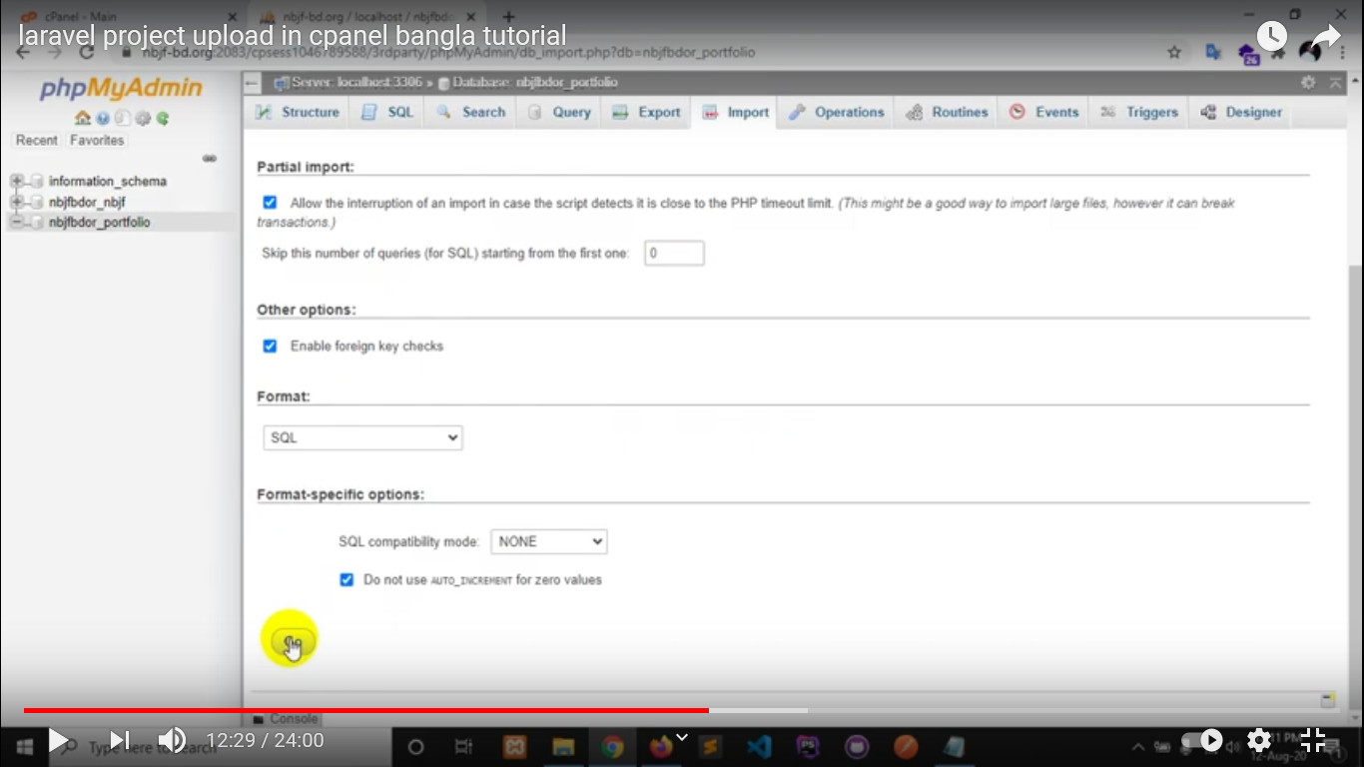

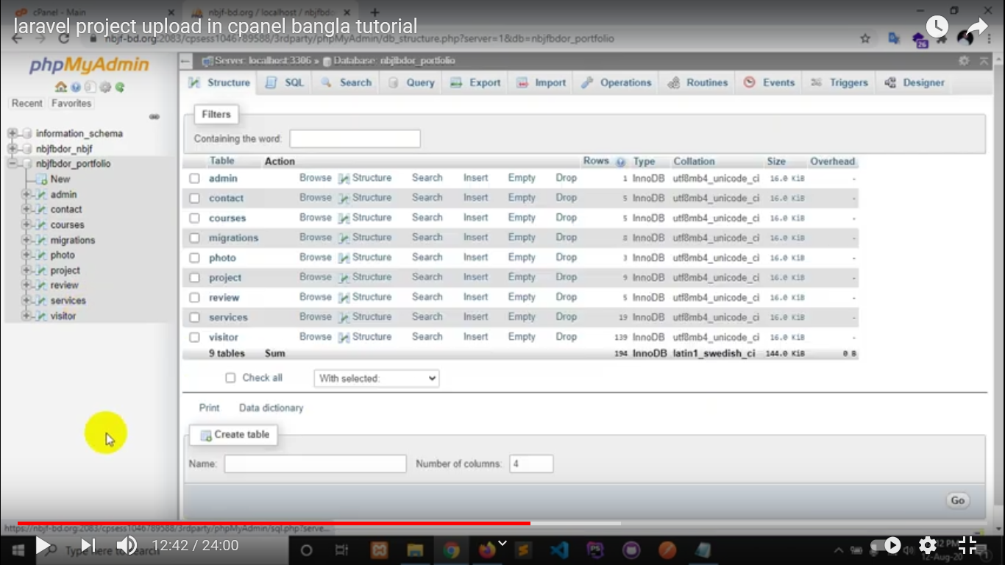

Database upload task is finish.

**How to Project Upload**

Go to File Manager

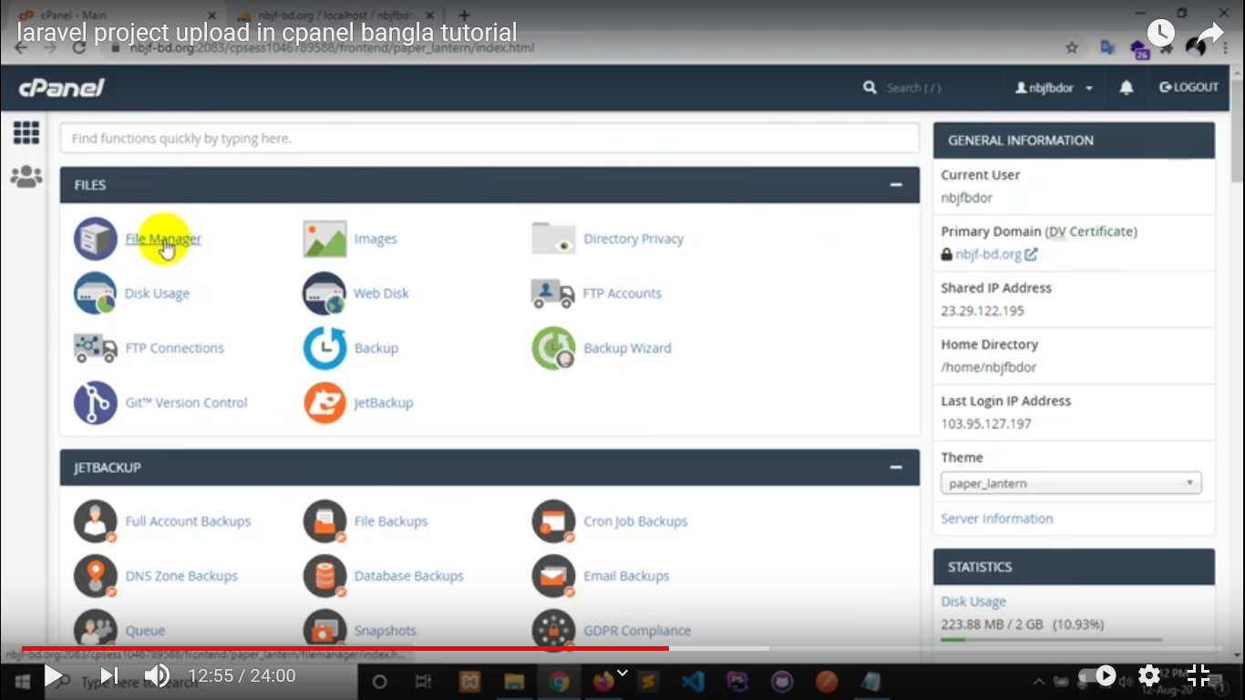

Click on “File Manager”

We have to know that there are two way to set project in Cpanel

1. In main domain
2. In sub domain

**How to set Project in Main Domain:**

1. Put project zip file in “public_html” and extract it and move all the file and folder to public_html
2. Go to public folder, select all and move to public_html
3. Open “index.php” file, in line 24 and 38 remove (../) before vendor and bootstrap path
4. Open “Config” folder and go to “app.php” and open it. Go to line 57, set domain path in asset url
5. Create a database, save db name, username, password in a note pad
6. Import database file
7. Set database name, username and password in .env file

index.php

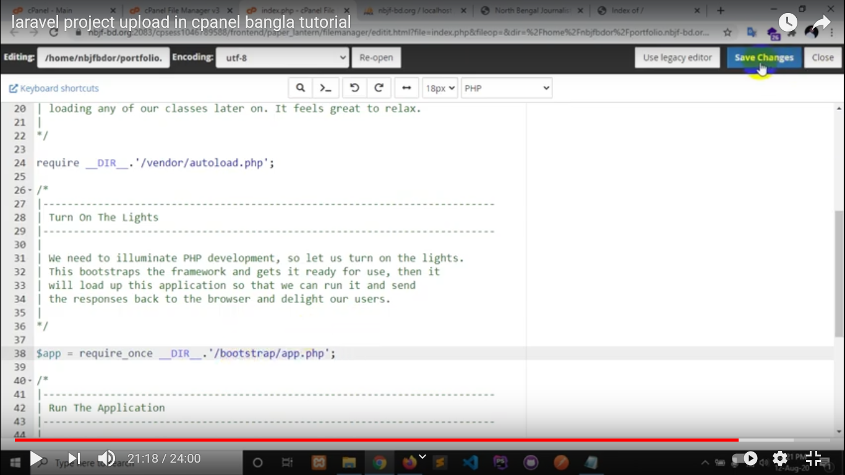

In Config/app.php, set domain path

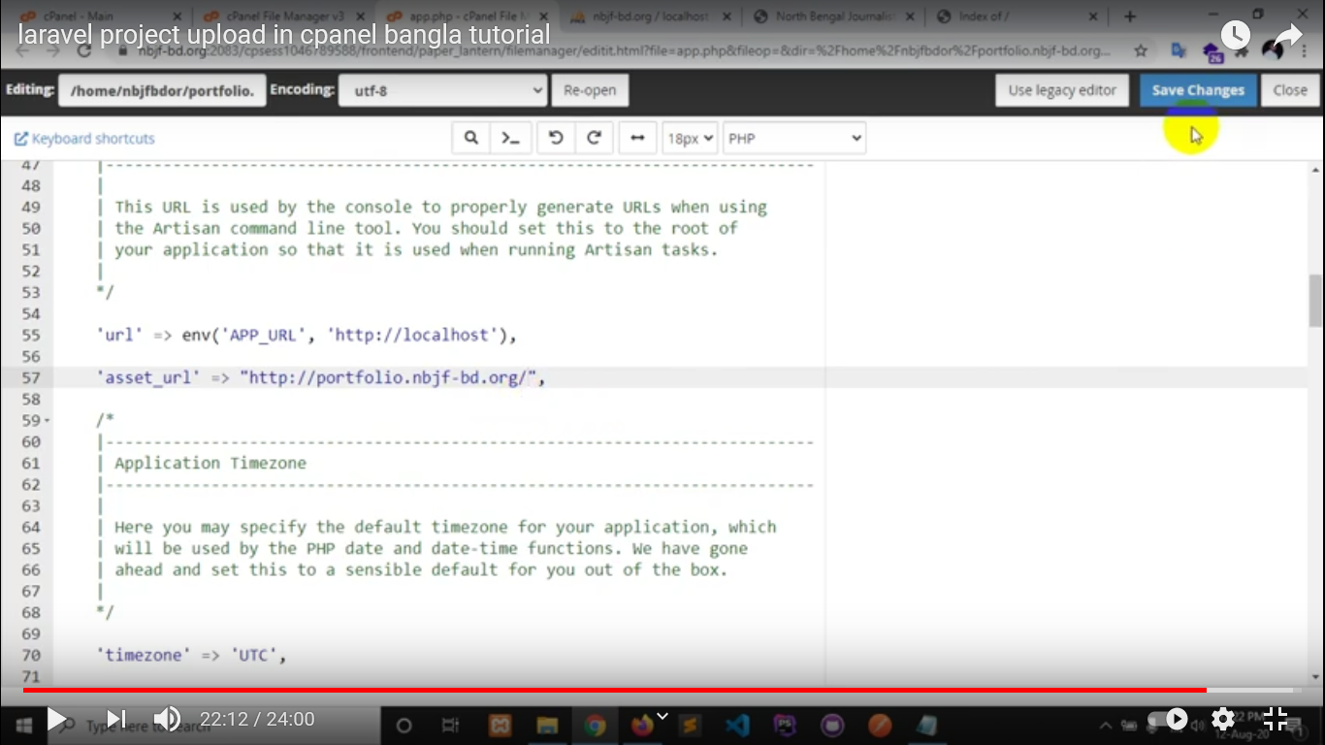

**How to set Project in Sub Domain:**

Create a subdomain

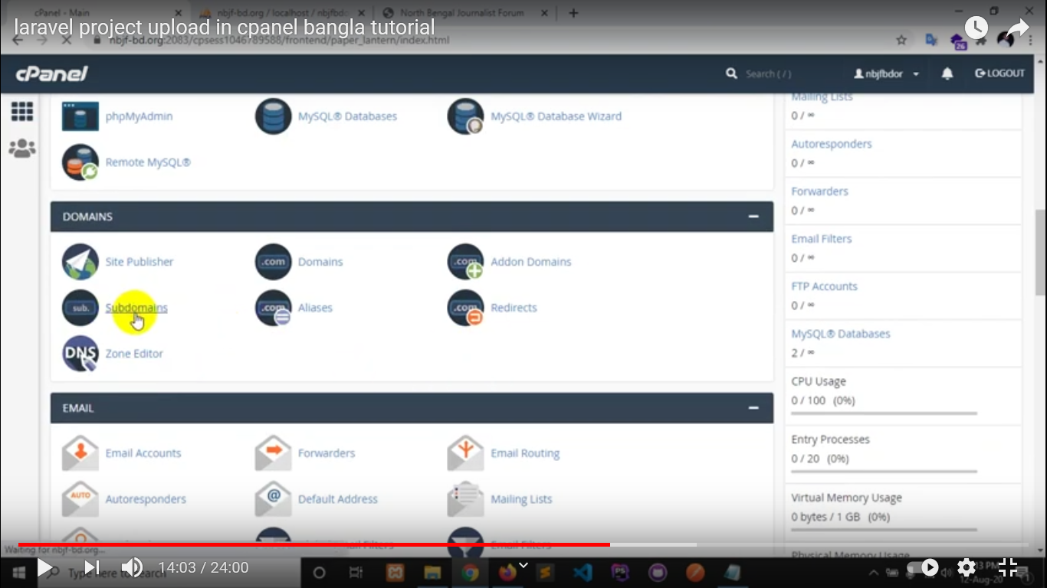

Give a subdomain name

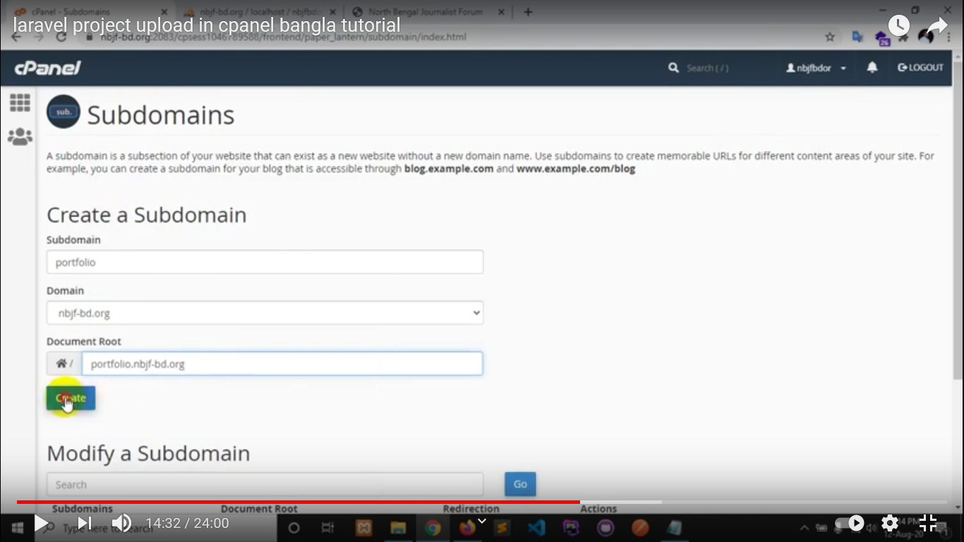

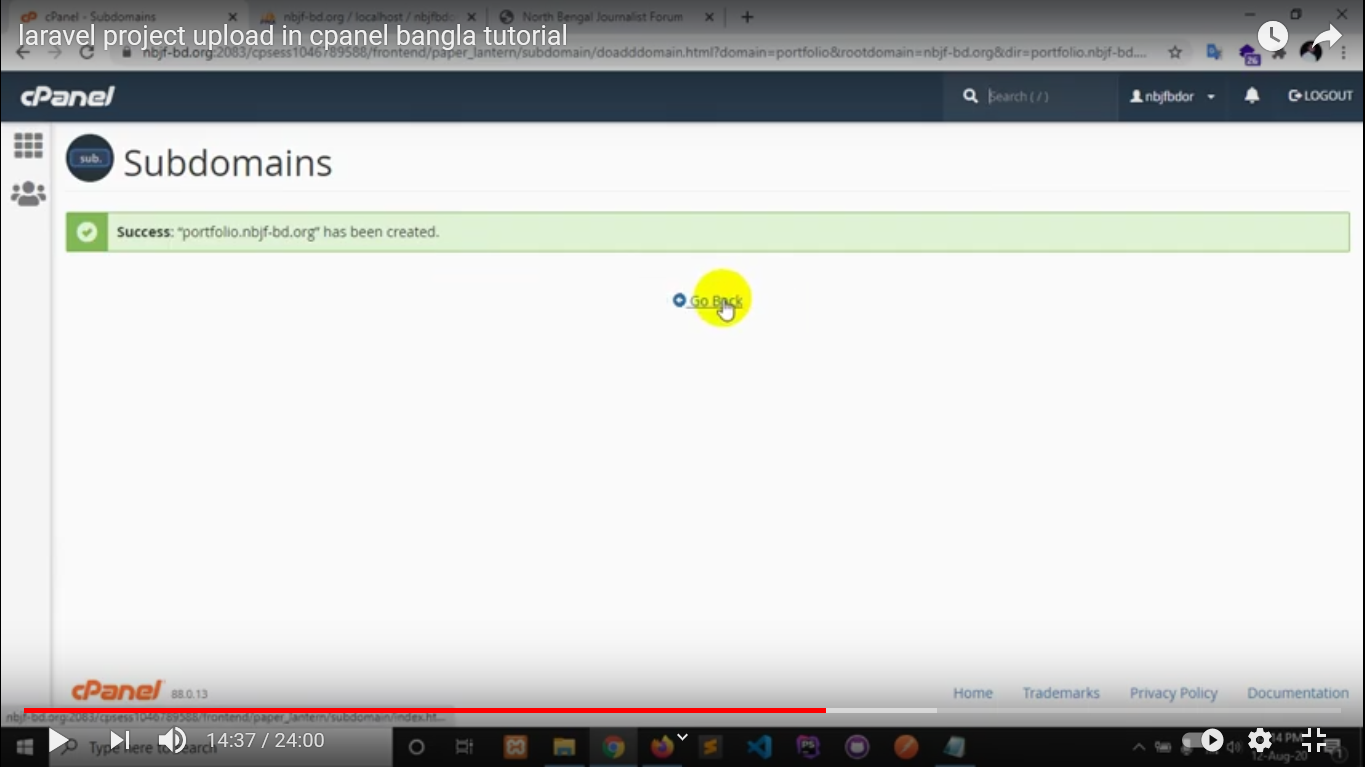

After created Subdomain, go to File Manager

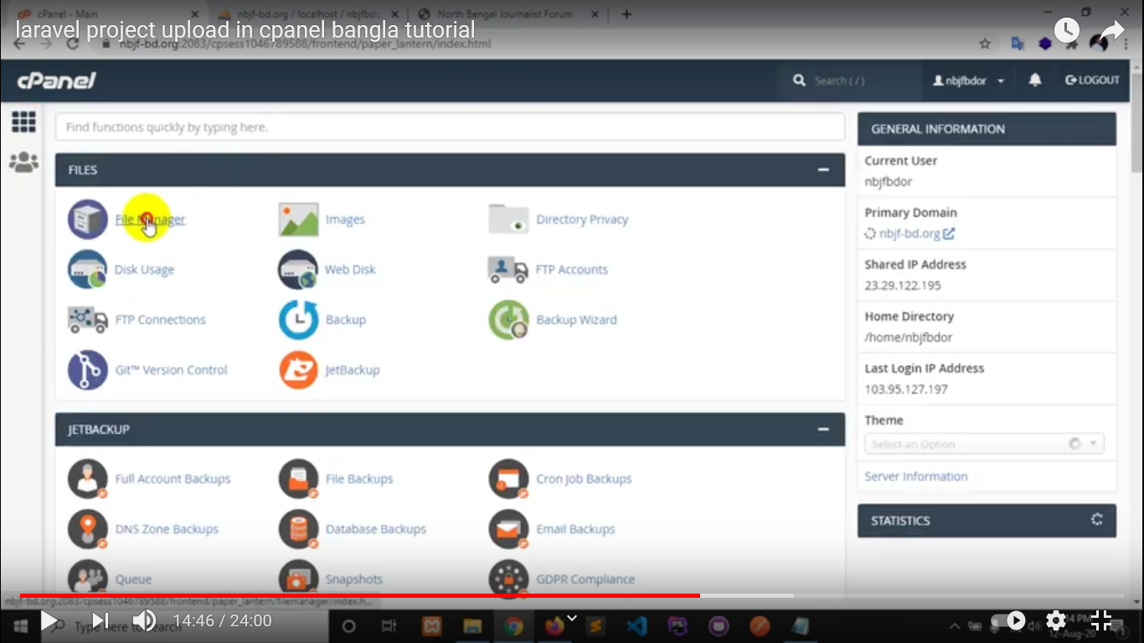

Select your Subdomain folder

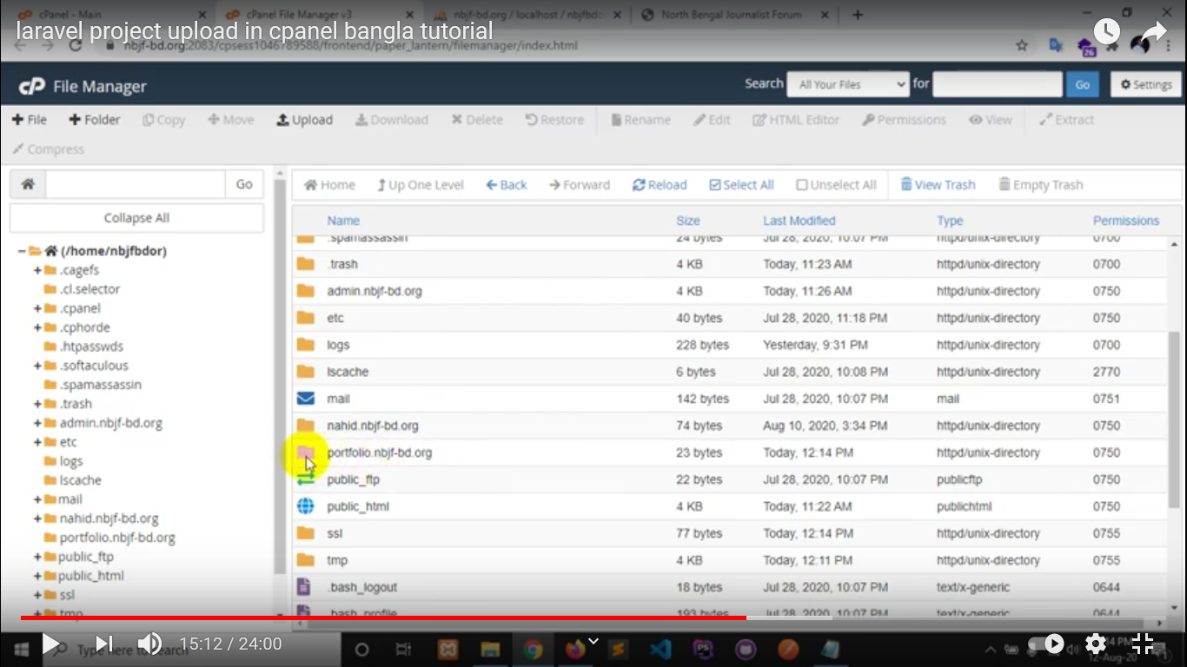

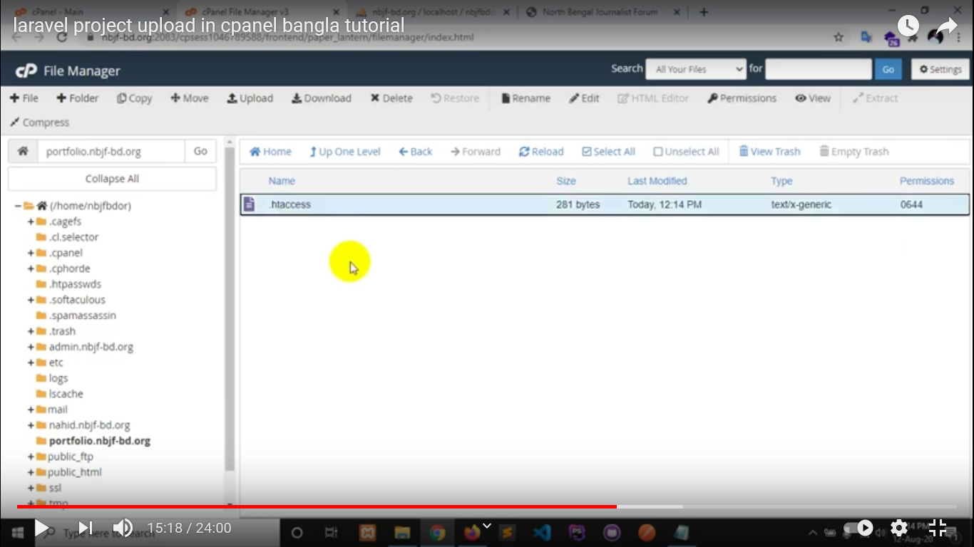

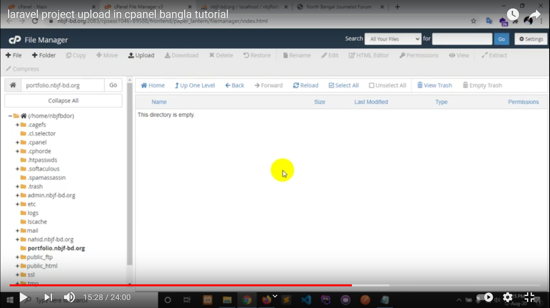

Now upload your project zip file

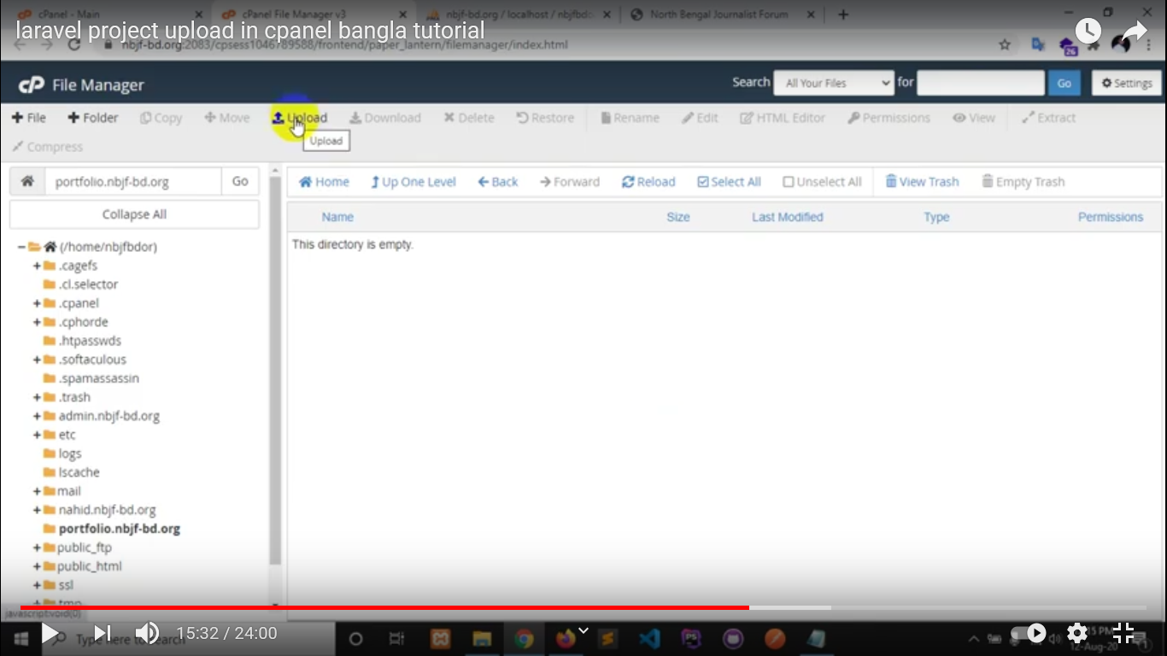

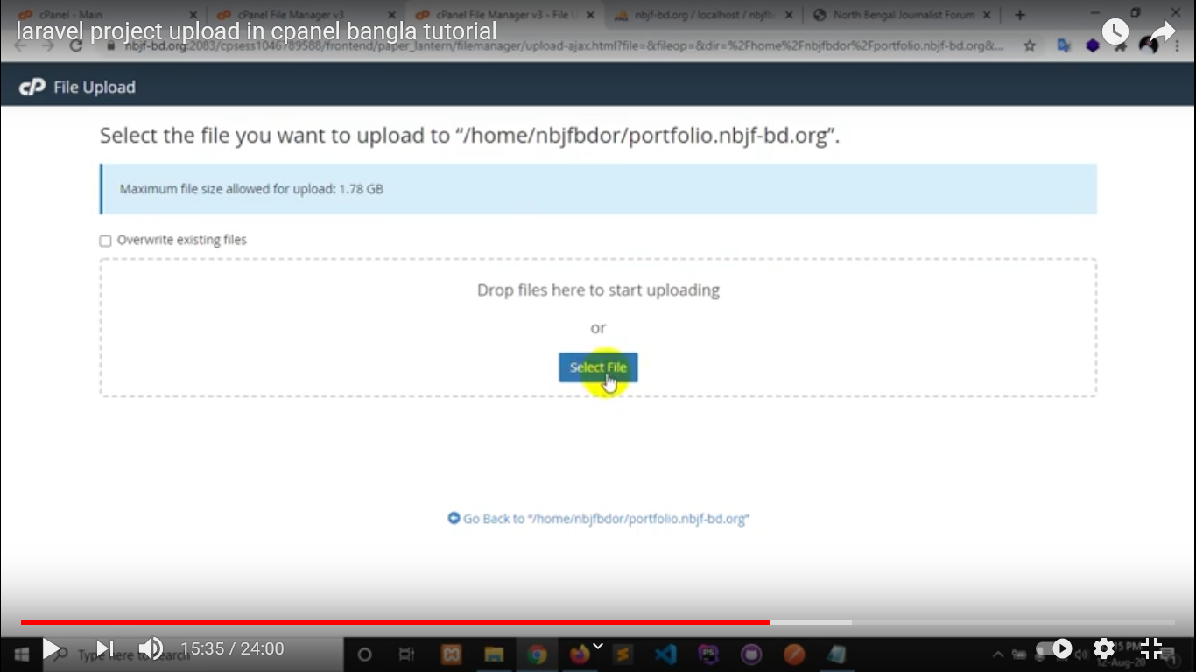

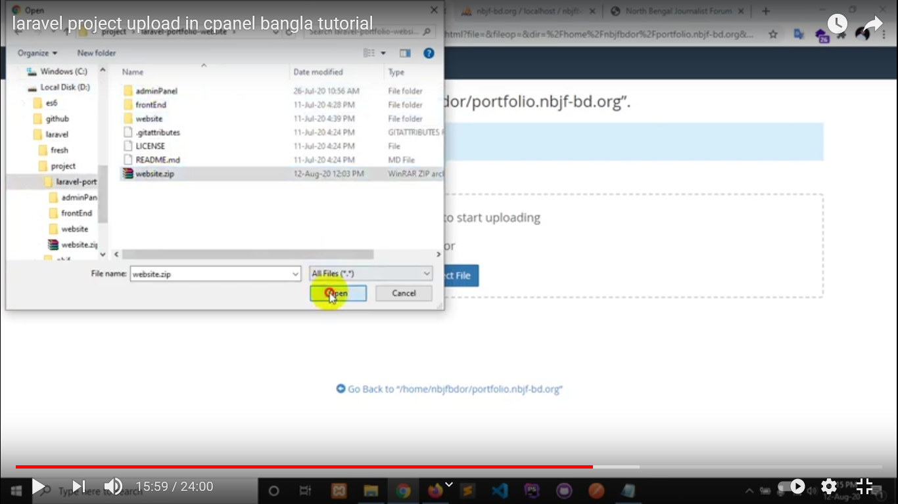

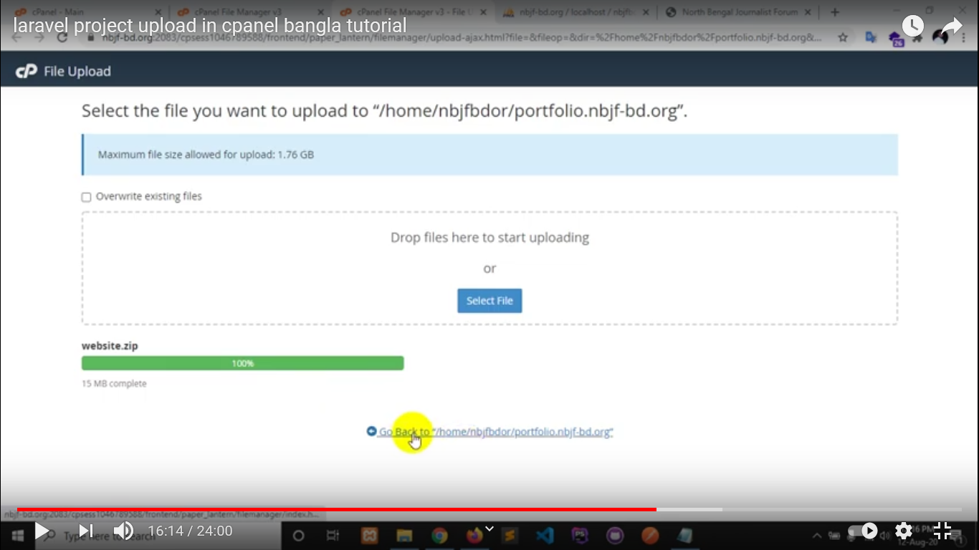

Extract the uploaded zip file

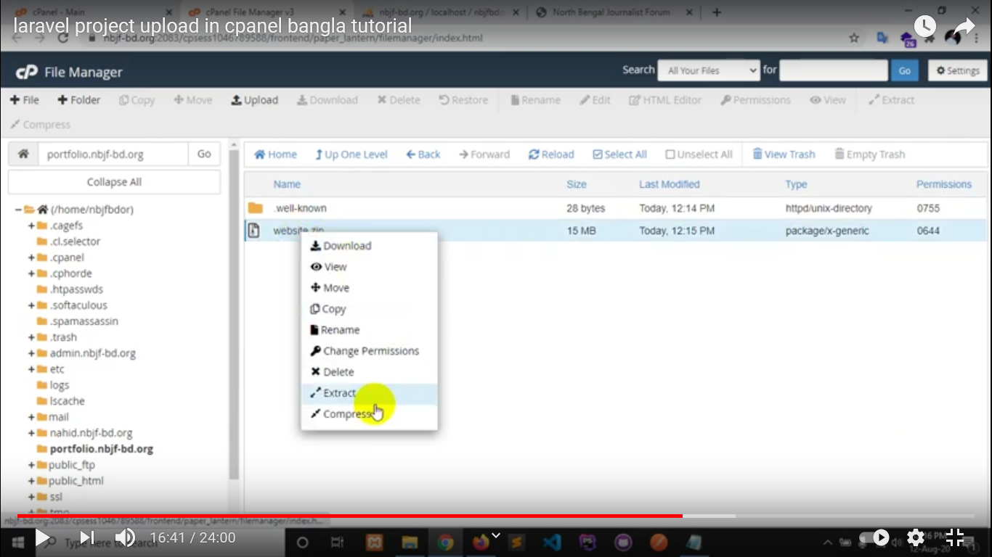

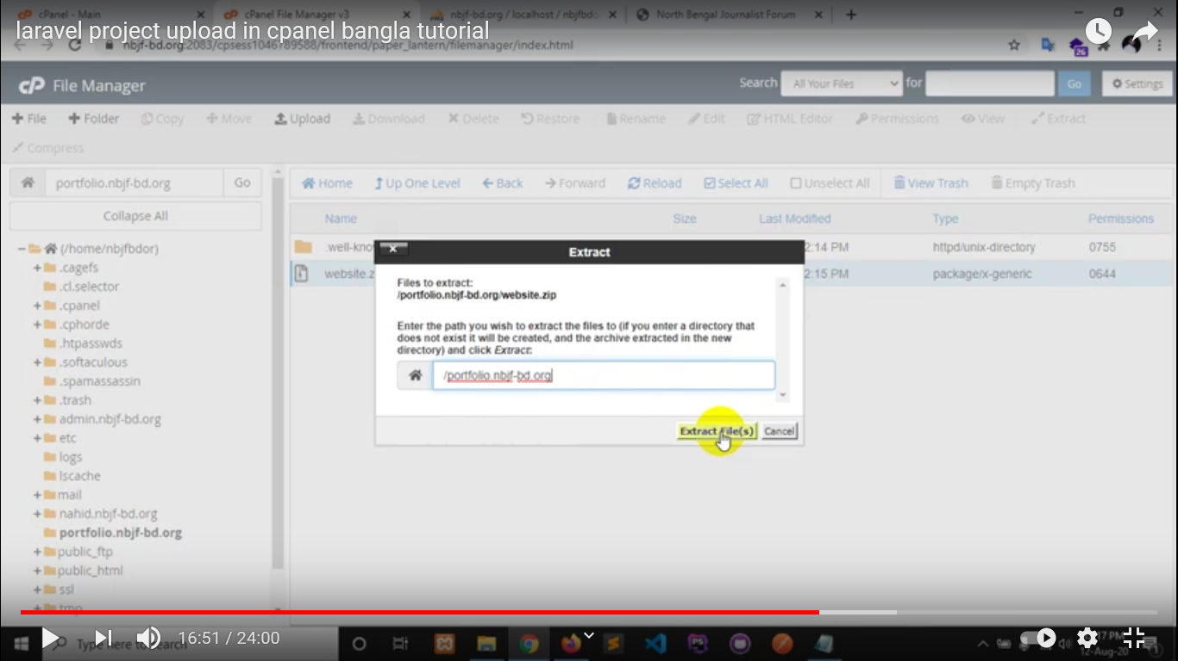

Now, delete zip file that are not need

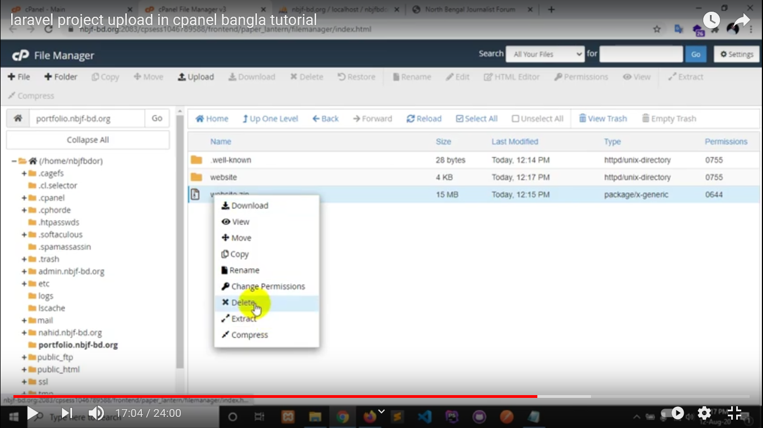

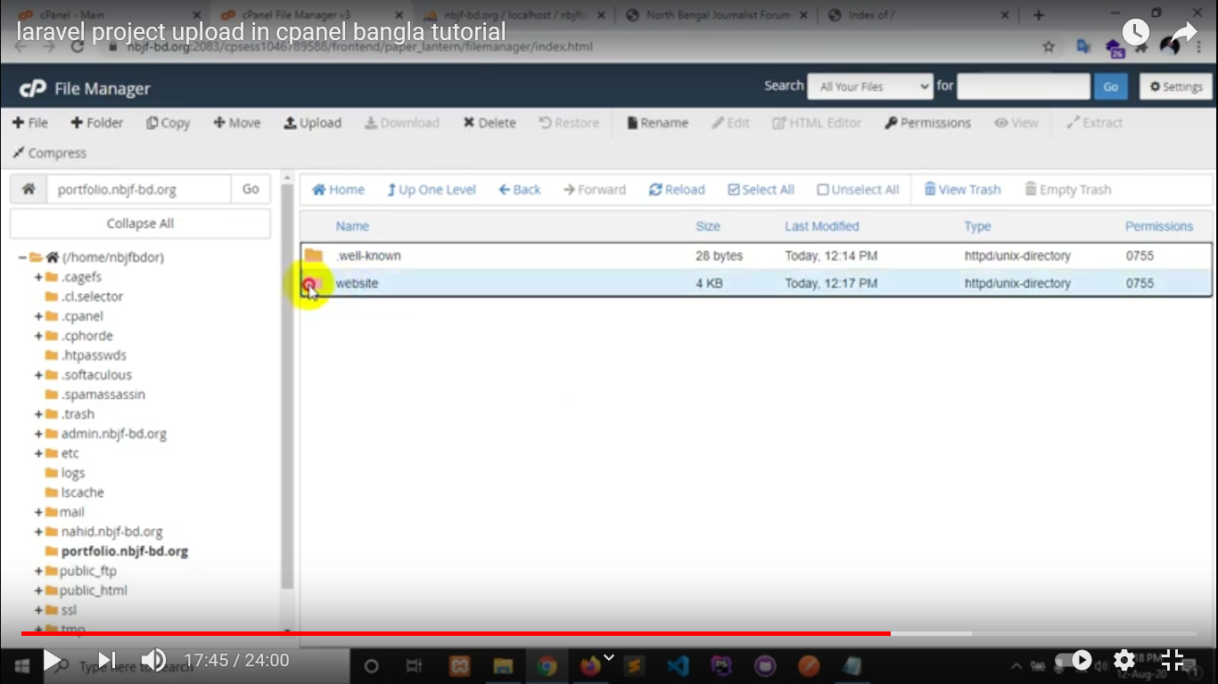

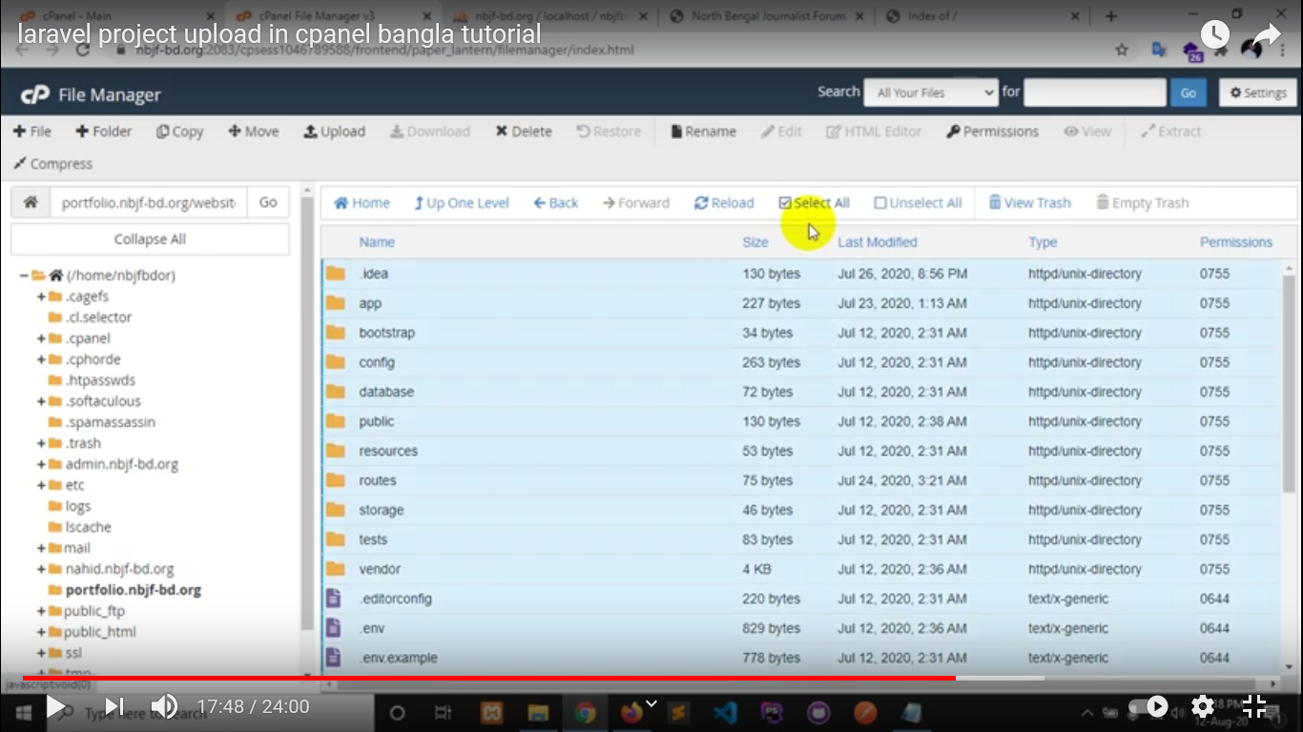

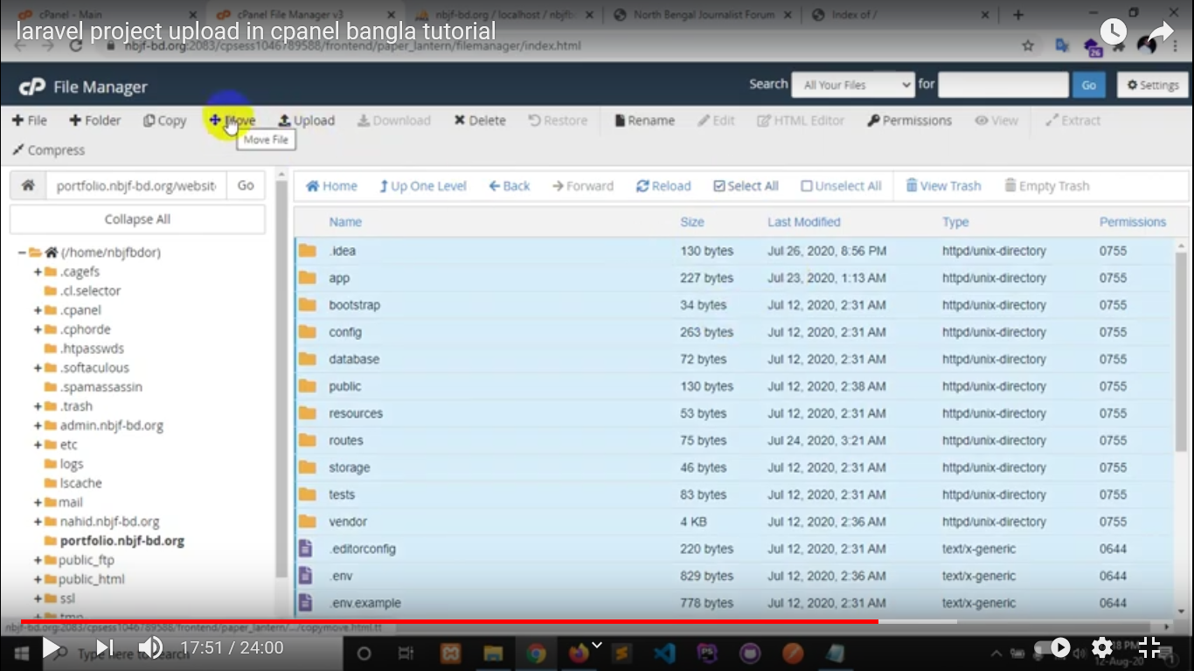

Remove

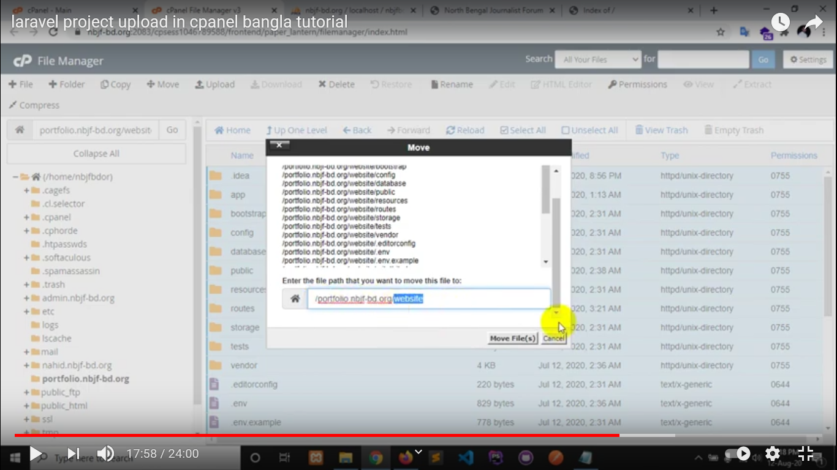

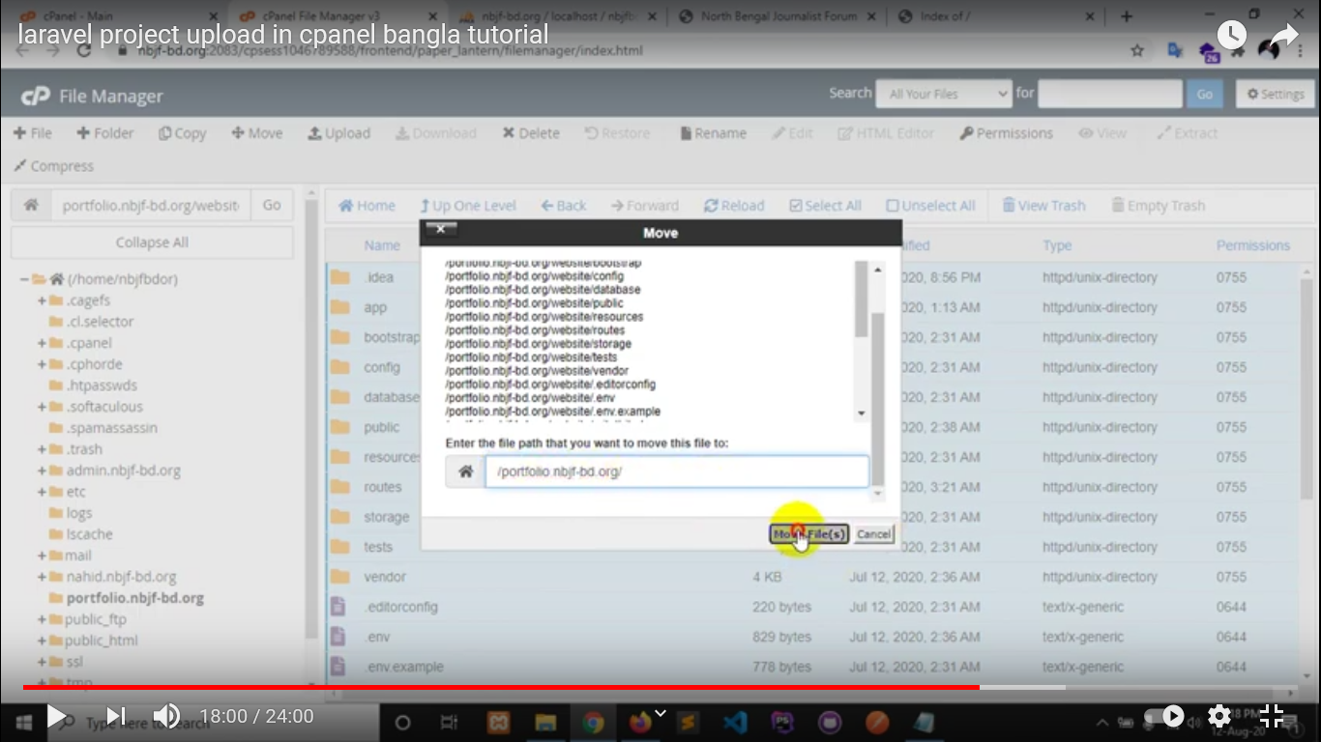

To see hidden file and folders , go and click on “setting”

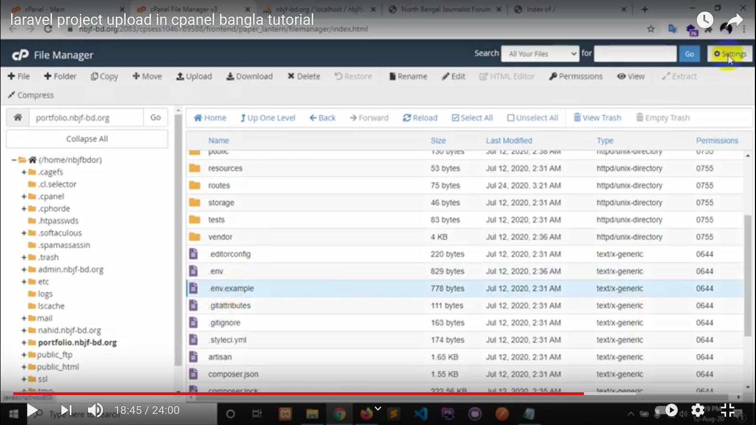

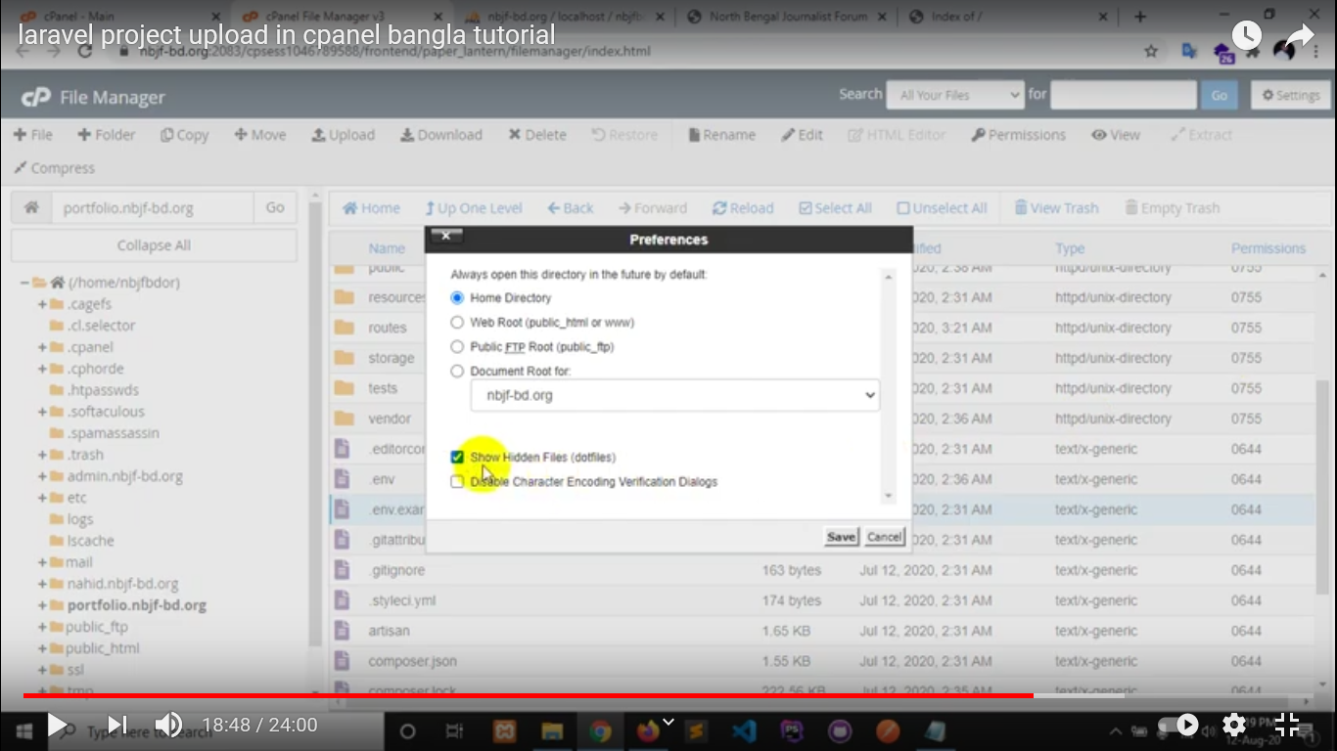

Now open .env file for database connection

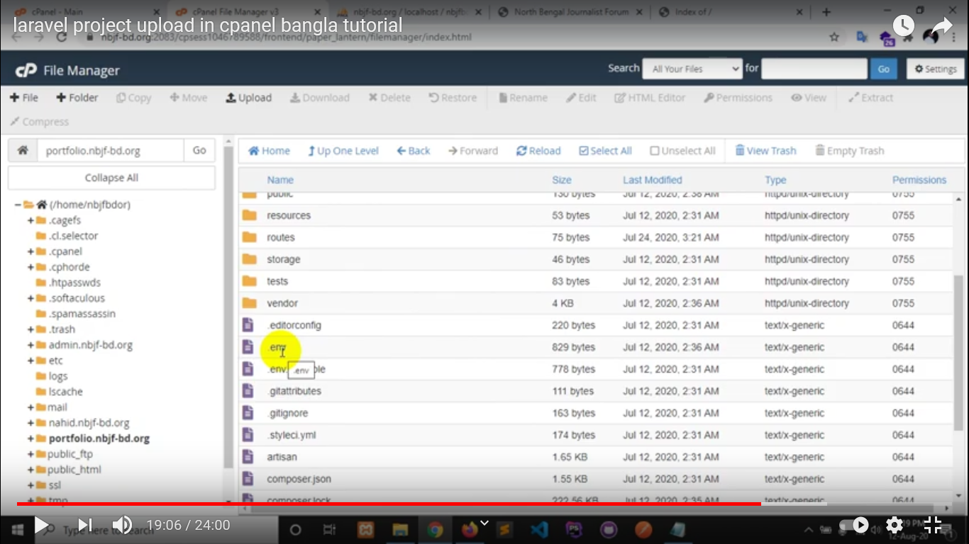

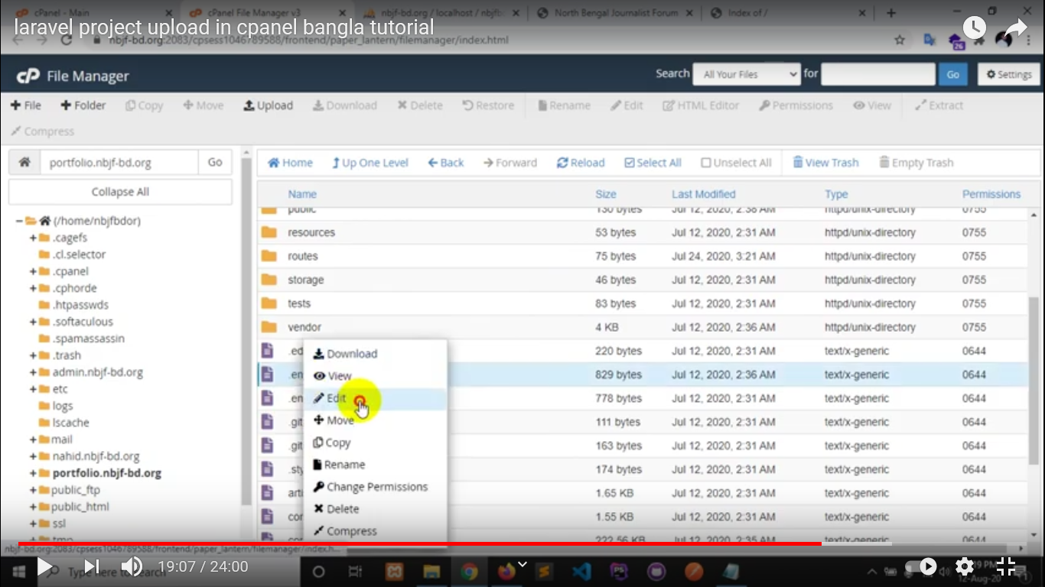

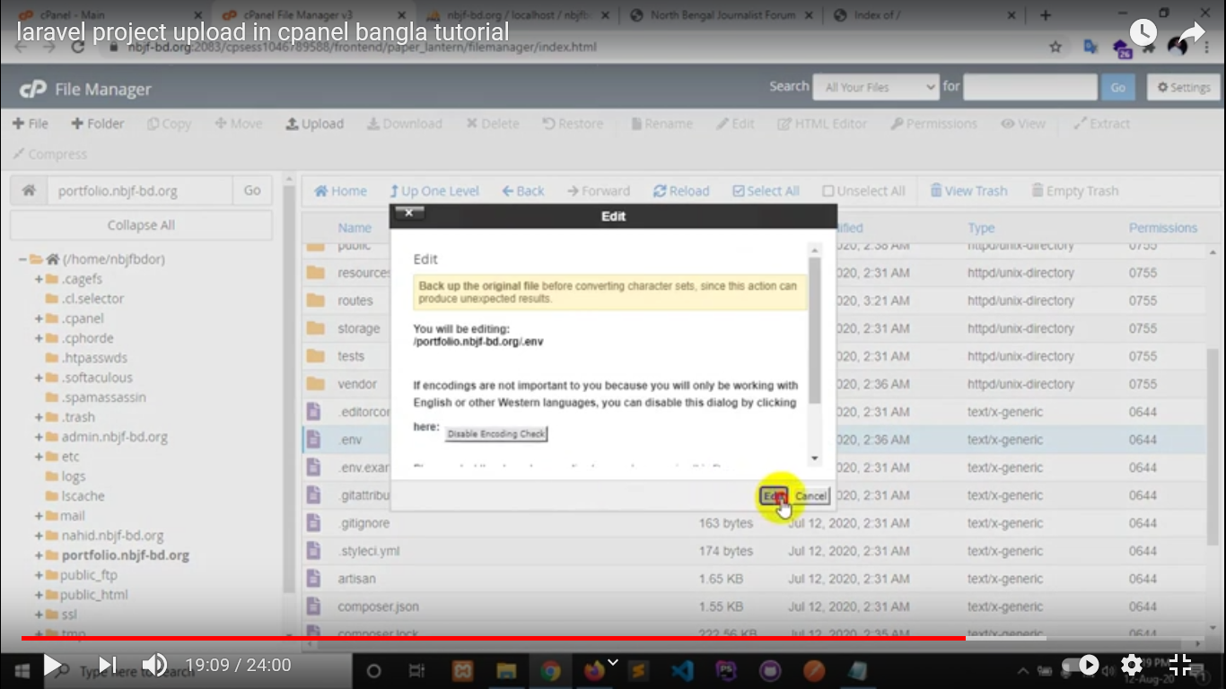

Set db name, username, password and click on “Save Changes” to save

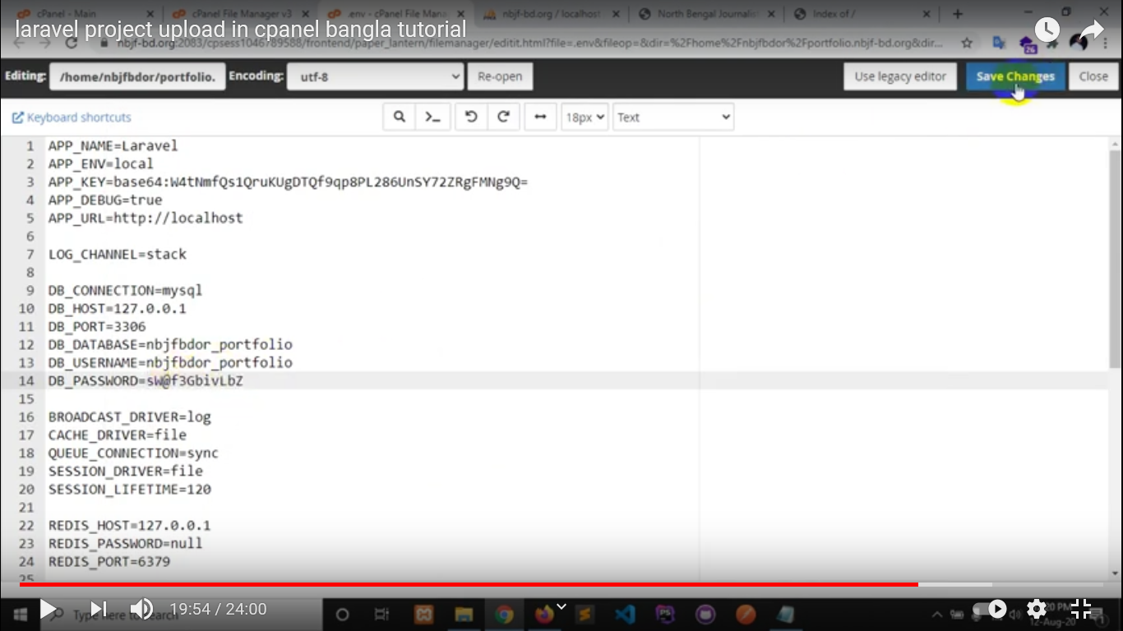

Now, go to public folder

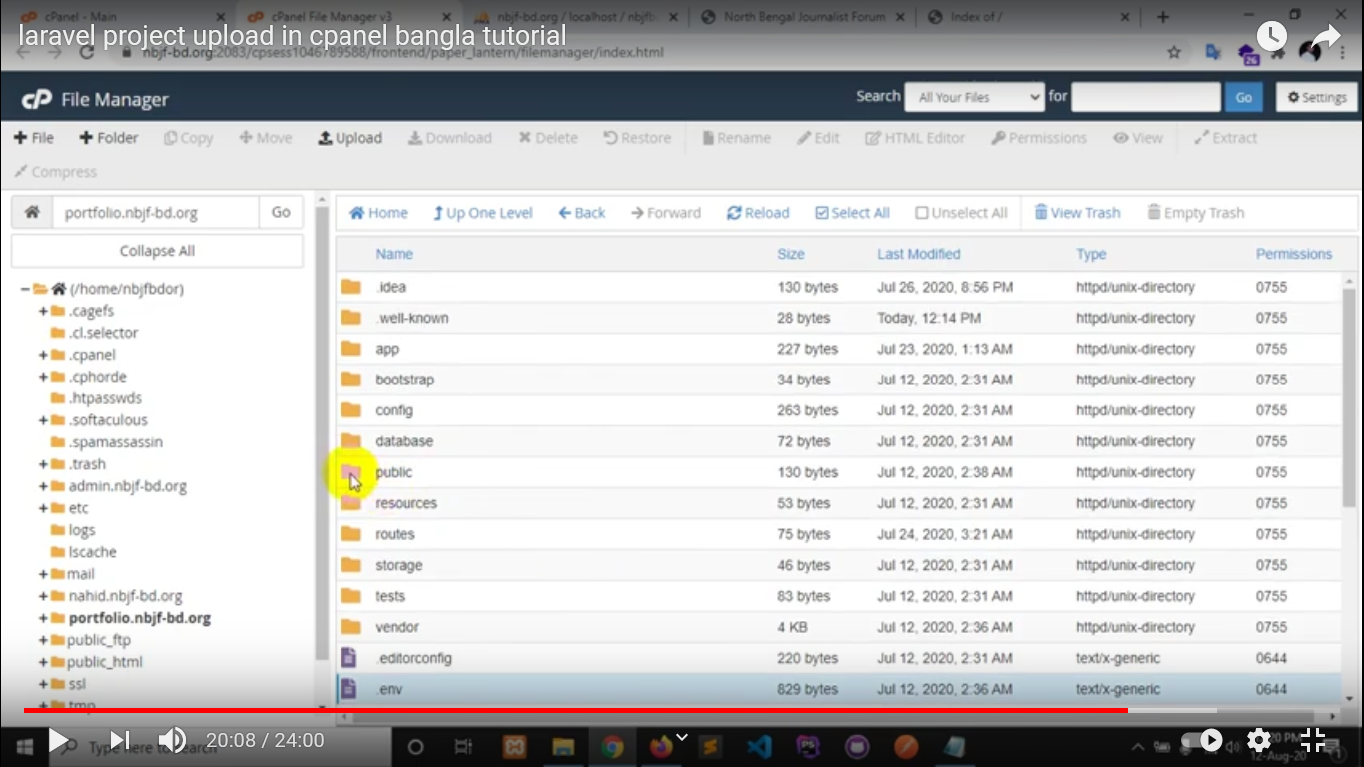

Select all file and folders in public folder and move to subdomain folder

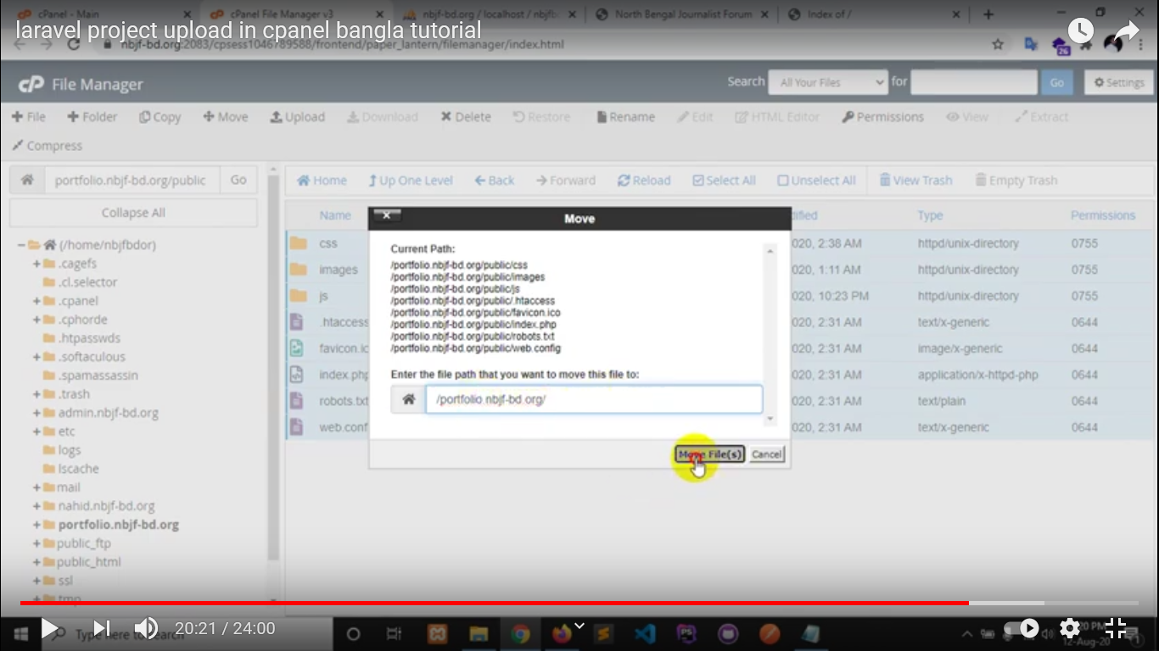

Now, go to index.php in subdomain and open it

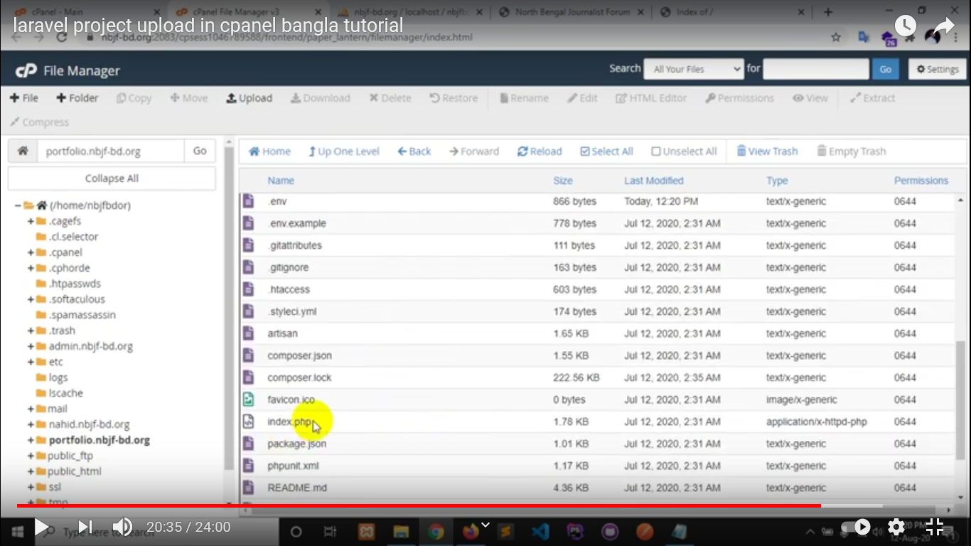

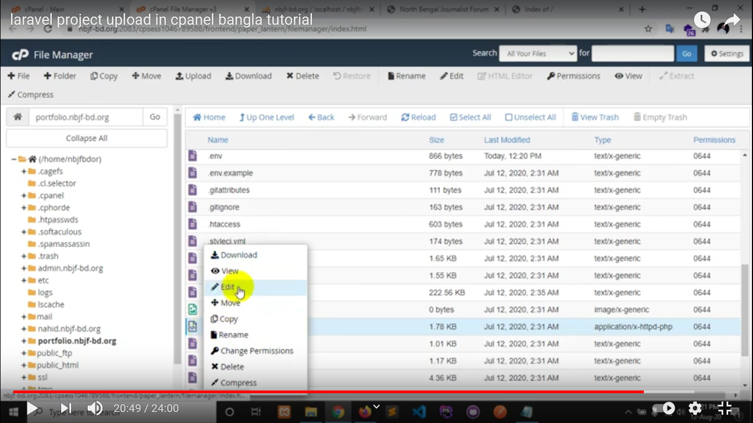

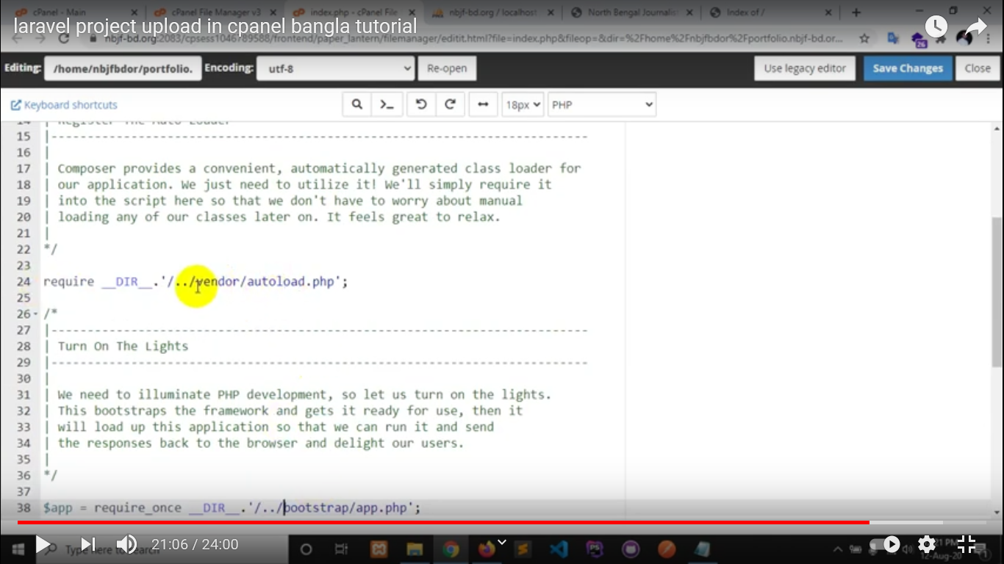

In line number 24 and 38 (vendor & bootstrap), need to remove (../)

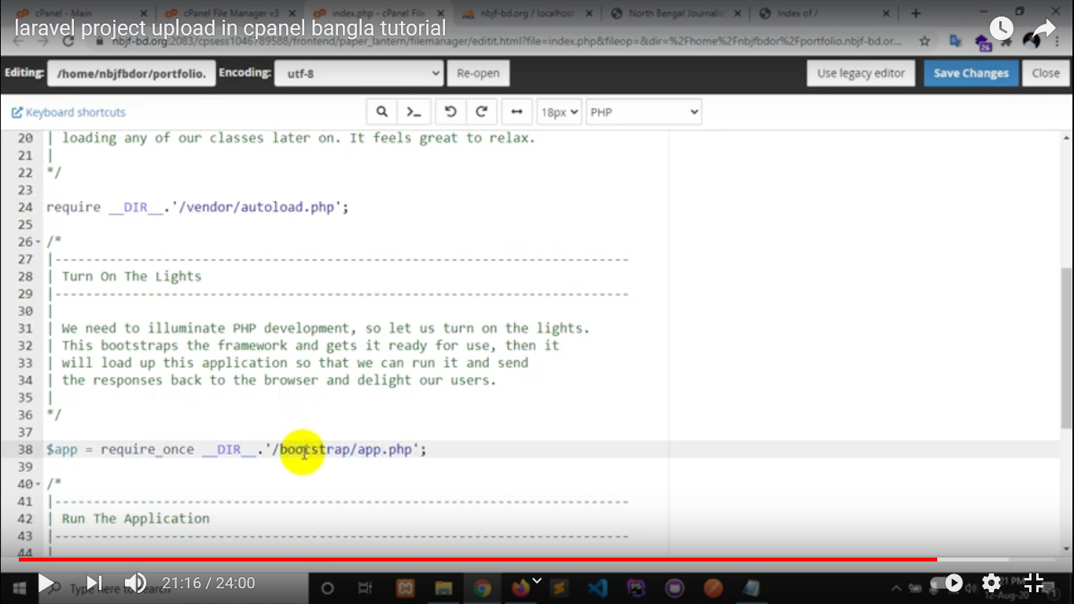

Click on “Save Changes”



Now go to config Folder

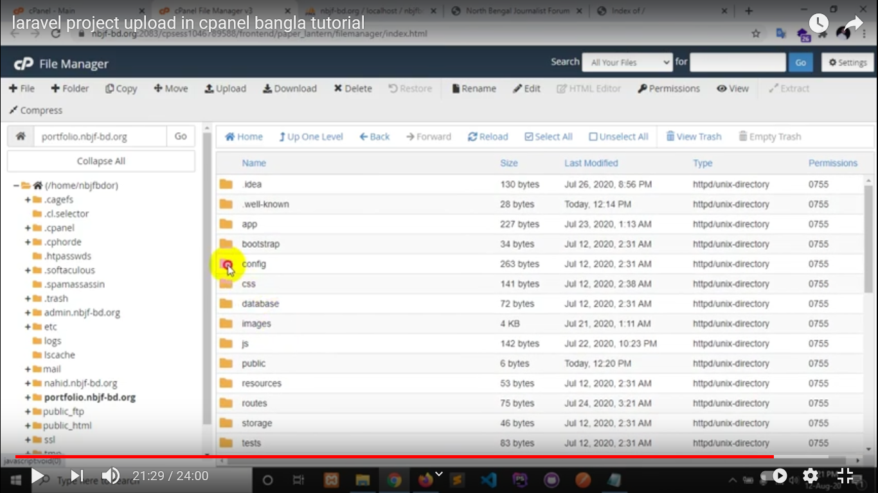

Open “app.php” file

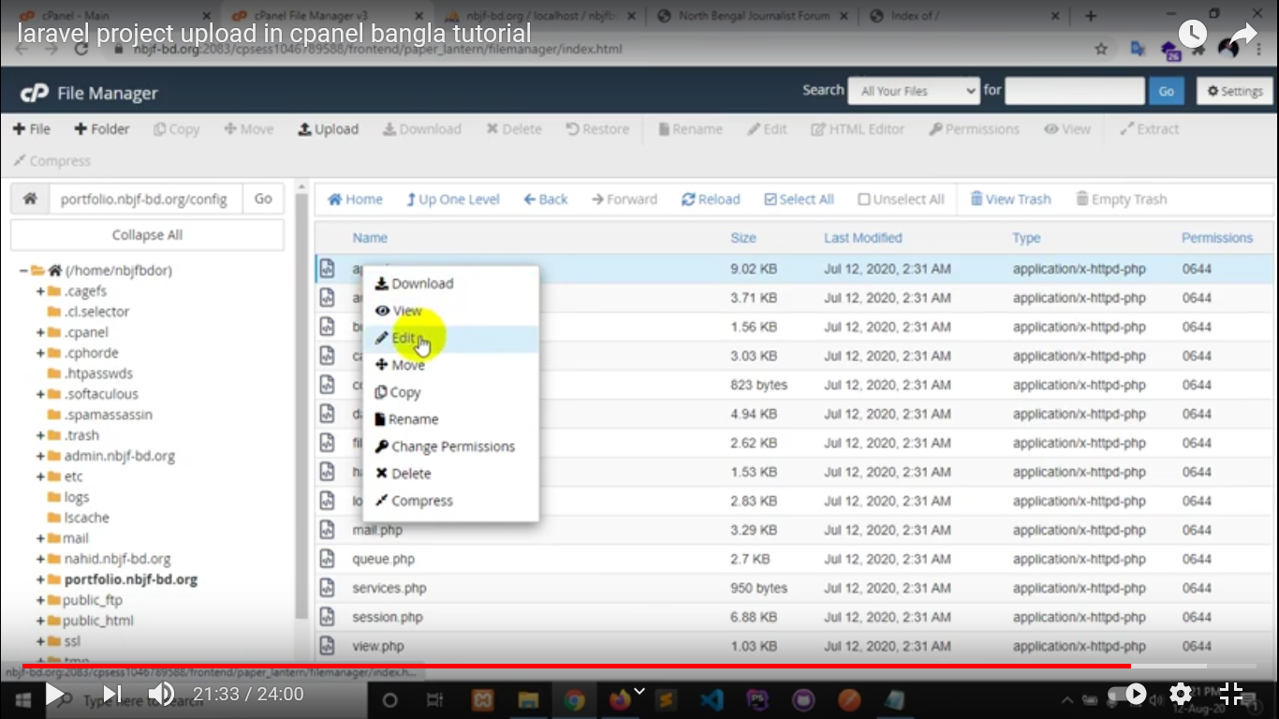

Change text in 57 line

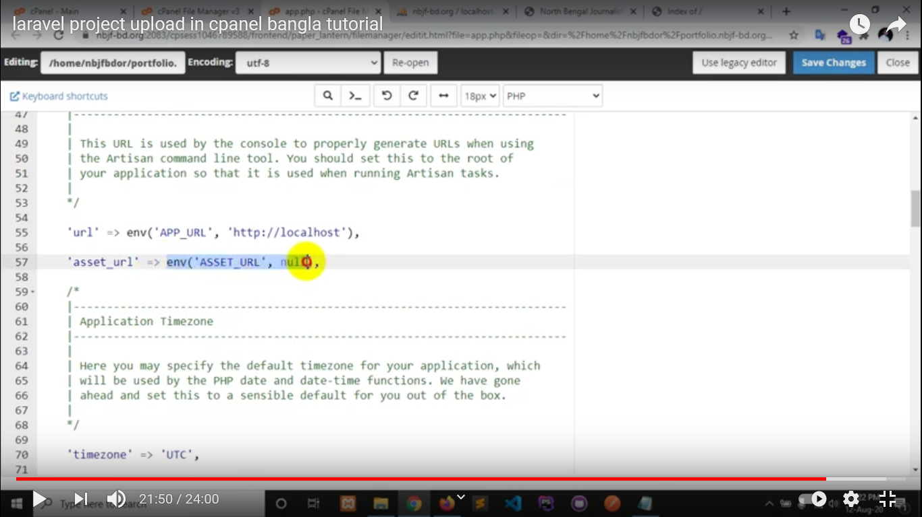

Set your domain url (web site url) here and click on “Save Changes” button



Now refresh your browser, try to open your website. Thank you.

If you need follow the tutorial

<https://youtu.be/VIwZ1oylwsI>